ALL SAINTS PUBLIC SCHOOL
HISTORY (027) Class XII: 2024-25 HALF YEARLY QUESTION PAPER

Time Allowed: 3hrs
Maximum Marks:80

General Instructions:
- Question paper comprises five Sections – A, B, C, D and E. There are 34 questions in the question paper. All questions are compulsory.
- Section A – Question 1 to 21 are MCQs of 1 mark each.
- Section B – Question no. 22 to 27 are Short Answer Type Questions, carrying 3 marks each. Answer to each question should not exceed 60-80 words.
- Section C - Question no 28 to 30 are Long Answer Type Questions, carrying 8 marks each. Answer to each question should not exceed 300-350 words.
- Section D – Question no.31 to 33 are Source based questions with three sub questions and are of 4 marks each.
- Section-E - Question no. 34 is Map based, carrying 5 marks that includes the identification and location of significant test items. Attach the map with the answer book.
- There is no overall choice in the question paper. However, an internal choice has been provided in few questions. Only one of the choices in such questions have to be attempted.
- In addition to this, separate instructions are given with each section and question, wherever necessary.

SECTION – A Marks
OBJECTIVE TYPE QUESTIONS (21 x 1 = 21)

Who among the following rulers rebuilt ‘Sudarshan Lake'?

  - Chashtra B)Smudragupta
- Rudradaman
- Vikramatitya

To which one of the following dynasties did raja Gotami-puta Siri-Satakani 1
belong?

- Vakataka
- Satvahana
- Kushan
- Gupta

Two statements are given in the question below as Assertion A and Reason R. 1
Read the statements and choose the appropriate option.

Assertion(R): Recovering artefacts is merely the initial step in the archaeological process.

Reason(R): Archaeologists employ various methods such as classification based on material and function, analysis of contextual clues, and reliance on indirect evidence to understand the significance and purpose of artefacts.

Options:
- Both (A) and (R) are correct and (R)is the correct explanation of (A)
- Both (A) and (R) are correct, but (R) is not the correct explanation of (A)
- (A) is correct, but (R) is not correct
- (R) is correct, but (A) is not correct.

Consider the following statements regarding Buddhism and choose the correct 1
option.
- The concept of Bodhisattva is central to Hinayana sect of Buddhism.
- Bodhisattva is a compassionate one on his way to enlightenment. III. Bodhisattva achieve nibbana for personal salvation.

Options
- II & III
- II &III
- I & II
- I & III

Match the column I with column II regarding the archaeologist who worked in the exploration of Indus valley and choose the correct option.

Column I |  | Column II
a | Daya Ram Sahni | i | Authored “Mohenjodaro & the Indus  Civilisation”
b | Rakhal Das Banerji | ii | Discovered seals at Harappa
c | John Marshall | iii | Found seals at Mohenjodaro
d | R.E.M. Wheeler | iv | Authored “Ancient India”

Options
(a) (b) (c) (d)
A. (iii) | (i) | (ii) | (iv)
B. (iii) | (iv) | (i) | (ii)
C. (i) | (ii) | (iii) | (iv)
D. (i) | (ii) | (iv) | (iii)

- Identify the ruler of the ancient India with the help of following information: 1
He was a prominent Shaka ruler.
He rebuilt Sudarshana Lake in the second century CE.

He showcased his engagement with Sanskritic traditions.

- Vikramaditya II
- Bhaskaravarman
- Bimbisara
- Rudradaman

Identify which of the following options refers to the ancient cave painting given 1
below?

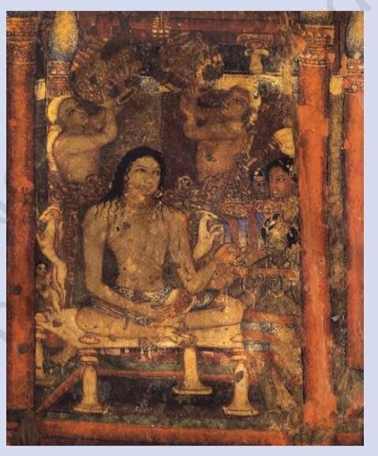 Source -NCERT
- Ajanta Cave Paintings
- Bagh Cave Paintings
- Sittanavasal Cave Paintings
- Ellora Cave Paintings

Which of the following skills can be identified from Al-Biruni's writings? 1

- Proficiency in diplomacy and political negotiation.
- Fluency in multiple languages and a broad intellectual curiosity.

- Expertise in military strategy and warfare tactics.
- Exceptional talent for storytelling and vivid descriptions.

Which of the following statements is incorrect about Andal? 1

- Andal was a woman Alvar, the most striking features of her compositions were widely sung.
- Andal was a woman Nayanar, she incorporated the prevailing caste system in the society.
- Andal saw herself as the beloved of Vishnu; her verses express her love for the deity.
- Andal saw herself as the beloved of Krishna; her verses express her love for the deity.

10 Is a collection of verses composed by bhikshunis.
- Therigatha
- Buddhacharita
- Sutta Pitaka
- Mahabharata
- Which of the following settled down in India and never returned to his country?
  - Duarte Barbosa
  - Manucci
  - Abdur Razzaq
  - jean Tavernier
- The Padmavati was composed by…
  - Baba Farid
  - Malik Muhammad Jaysi.
  - Kabir
  - Guru Nanak
- The Indus Valley people knew the use of……
- gold, copper, bronze but not iron.
- copper, iron, gold but not bronze.
- silver, lead, iron but not gold.
- gold, tine, bronze, but not copper.
- Which of the following was a non. Buddhist symbol used to decorate the stupa?
  - Shalabhanjika
  - Tree
  - Wheel
  - Stupa
- Evidence of a ploughed field was found at
- Banawali
- Cholistan
- Kalibangan
- Shortughai.
- Who among the following rulers worked on the preservation of Sanchi Stupa?
- Ruksar Begum
- Jahanara Begum
- Roshnara Begum
- Shahjahan Begum.

- Jagannatha is a form of…..
- Shiva
- Vishnu
- Brahma
- Rudra
- Which of the following foreign powers wanted to take away the eastern gateway of Sanchi Stupa to their own country?
- Norwegian
- French
- Scottish
- Portuguese
- Match The Following.
- Birth of Buddha i) Bodh Gaya
- Enlightenment ii ) Lumbini

- First Sermon iii) Kusinagara
- Death of Buddha iv) Saranath.
- identity the text with the help of the following information.
* It is one of the best known legal texts of early India.
- Written in Sanskrit.
- Compiled between 2nd century BCE and 2 nd century CE Choose a appropriate option
( Dharmashastra, Upanishads, Mahabharata, Manusmriti)
- Which one of the following kings adopted the titles of devaputra “ Son of God “ ( Harsha, Asoka, Kanishka, Chandragupta II )

SECTION B
SHORT ANSWER TYPE QUESTIONS (6 x 3 =18)

- A. Analyse the layout of Harappan cities to identify features that promoted cleanliness 3 and public health.

OR

Examine the challenges historians face in deciphering the Harappan script. 3

- How does the Mahabharata show the multicultural nature of ancient Indian society? 3 Explain with examples.
- A. Examine the impact of Bhakti and Sufi poetry on the development of regional 3 languages and literature.

OR

B. Examine how music and devotional songs in Bhakti and Sufi traditions serve 3 spiritual expression and community unity.
- Why were land grants given and to whom?

- Analyse the role of Indian Sanskritst V. S Sukthankar and his team in the preparation of critical edition of Mahabharata.

- Describe the basic structure of a stupa.

OR

What were the similarities and differences between the be-shari'a and ba-shari'a traditions?

SECTION C
LONG ANSWER TYPE QUESTIONS (3 x 8 =24)

- A. Describe some of the distinctive features of Mohonjodaro..

OR

B. What kind of agricultural practices existed in the Harappan Civilization?

- A. What were the different explanations offerred by the early writers and historians for the growth of Magadha as a powerful Mahajanapada? Explain.

OR

B.‘ Highlight the elements considered by the historian’s while analyszing the Mahabharata.

- A. Discuss the evidence that suggests that Brahmanical prescriptions about kinship and marriage were not universally followed.

OR
B. Write a short note on the life of Francois Bernier.

SECTION D
SOURCE BASED QUESTIONS (3 x 4 = 12)

Read the following source carefully and answer the questions that follow: 1+1+2
=4

Inscriptions

Inscriptions are writings engraved on hard surfaces such as stone, metal, or pottery. They usually record the achievements, activities, or ideas of those who commissioned them and include the exploits of kings, or donations made by women and men to religious institutions. Inscriptions are virtually permanent records, some of which carry dates. Others are dated on the basis of palaeography or styles of writing, with a fair amount of precision. For instance, in c. 250 BCE the letter “a” was written like this: By
c. 500 CE, it was written like this: The earliest inscriptions were in Prakrit, a name for languages used by ordinary people. Names of rulers such as Ajatasattu and Asoka, known from Prakrit texts and inscriptions, have been spelt in their Prakrit forms in this chapter. You will also find terms in languages such as Pali, Tamil, and Sanskrit, which

too were used to write inscriptions and texts. It is possible that people spoke in other languages as well, even though these were not used for writing.

- What role does palaeography play in determining the age of inscriptions?
- How do inscriptions contribute to our understanding of ancient societies and cultures?
- What insights can be gained from studying the languages used in inscriptions across different regions and time periods?

32 Read the following source carefully and answer the questions that followed
1+1+2 =4

Translating texts, sharing ideas

Translating texts, sharing ideas Al-Biruni’s expertise in several languages allowed him to compare languages and translate texts. He translated several Sanskrit works, including Patanjali’s work on grammar, into Arabic. For his Brahmana friends, he translated the works of Euclid (a Greek mathematician) into Sanskrit.

  - Analyse the advantage Al-Biruni gained from his expertise in multiple languages?
  - Analyse the significance of Al-Biruni translating Patanjali's work on grammar into Arabic?
  - How did Al-Biruni's translations contribute to the mutual understanding and appreciation between Islamic and Indian civilizations?

33. Read the following source carefully and answer the questions that follow: 1+1+2
=4

The poor peasants’.

An excerpt from Bernier’s description of the peasantry in the countryside:
Of the vast tracts of country constituting the empire of Hindustan, many are little more than sand, or barren mountains, badly cultivated, and thinly populated. Even a considerable portion of the good land remains untilled for want of labourers., many of whom perish in consequence of the bad treatment they experience from Governors. The poor people, when they become incapable of discharging the demands of their rapacious lords, are not only often deprived of the means of subsistence, but are also made to lose their children, who are carried away as slaves. Thus, it happens that the peasantry, driven to despair by so excessive a tyranny, abandon the country.
In this instance, Bernier was participating in contemporary debates in Europe concerning the nature of state and society, and intended that his description of Mughal India would serve as a warning to those who did not recognize the “merits” of Private property.

- Name the book written by François Bernier on the critical insight and deflection on the empire of Hindustan.

- What description Bernier has given on the condition of Indian peasantry during the Mughal Empire?
- Which fundamental differences he found between Mughal India And Europe during the 16 th and 17 th century?

SECTION E  Map Based Question | (1 x 5 =  5)

34 (34 )On the given political map of India, locate and label the following with appropriate symbols:

- Sanchi– A Stupa
- Kalibangan
- Harappa
- Lothal
- Kotdiji

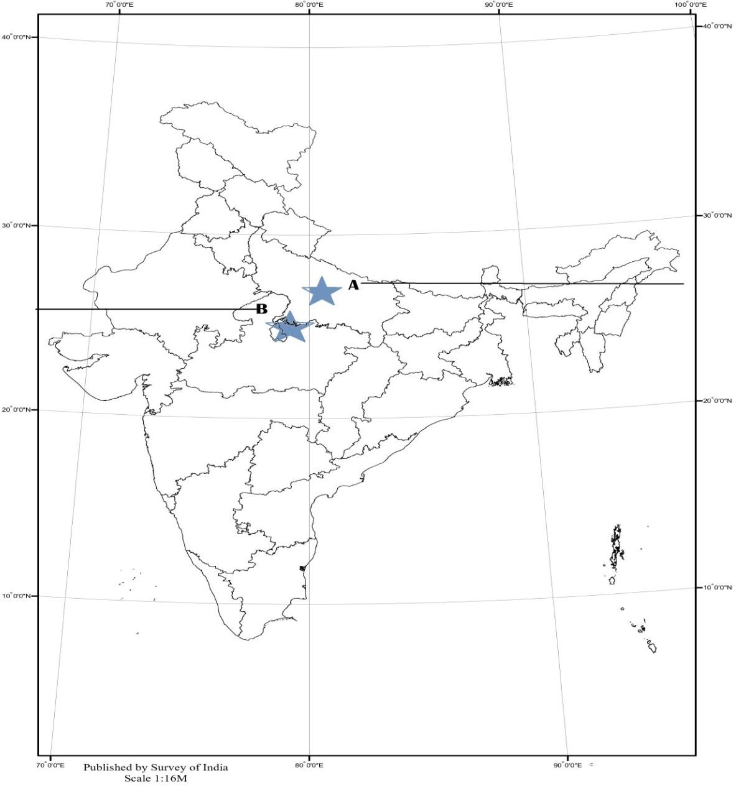

SQP-History-2024-25

