ALL SAINTS PUBLIC SCHOOL, CHAYAM. HALF YEARLY EXAMINATION.
STD: XII COMPUTER SCIENCE MARK:70

- Find the invalid identifier from the following
  - none
  - address
  - Name
  - pass
- Consider a declaration L = (1, 'Python', '3.14').
Which of the following represents the data type of L?
  - list
  - tuple
  - dictionary
  - string
- Given a Tuple tup1= (10, 20, 30, 40, 50, 60, 70, 80,
90).
What will be the output of print (tup1 [3:7:2])?
  - (40,50,60,70,80)
  - (40,50,60,70)

  - [40,60]
  - (40,60)
- Which of the following option is not correct?
  - if we try to read a text file that does not exist, an error occurs.
  - if we try to read a text file that does not exist, the file gets created.
  - if we try to write on a text file that does not exist, no error occurs.
  - if we try to write on a text file that does not exist, the file gets
Created.
- Which of the following options can be used to read the first line of a text file Myfile.txt?
  - myfile = open('Myfile.txt'); myfile.read()
  - myfile = open('Myfile.txt','r'); myfile.read(n)
  - myfile = open('Myfile.txt'); myfile.readline()
  - myfile = open('Myfile.txt'); myfile.readlines()
- Assume that the position of the file pointer is at the beginning of 3rd line in a text file. Which
of the following option can be used to read all the remaining lines?

  - myfile.read()
  - myfile.read(n)
  - myfile.readline()
  - myfile.readlines()
- A text file student.txt is stored in the storage device.
Identify the correct option out of the
following options to open the file in read mode.
- myfile = open('student.txt','rb')
- myfile = open('student.txt','w')
- myfile = open('student.txt','r')
- myfile = open('student.txt')
  - only i
  - both i and iv
  - both iii and iv
  - both i and iii
- The return type of the input() function is
  - string
  - integer
  - list
  - tuple

- Which of the following operator cannot be used with string data type?
a. +
- in
- *
- /
- Consider a tuple tup1 = (10, 15, 25, and 30).
Identify the statement that will result in an error.
  - print(tup1[2])
  - tup1[2] = 20
  - print(min(tup1))
  - print(len(tup1))
- Which of the following statement is incorrect in the context of binary files?
  - Information is stored in the same format in which the information is held in
memory.
  - No character translation takes place
  - Every line ends with a new line character

  - pickle module is used for reading and writing

- What is the significance of the tell() method?
  - tells the path of file
  - tells the current position of the file pointer within the file
  - tells the end position within the file
  - checks the existence of a file at the desired location
- Which of the following components are part of a function header in Python?
  - Function Name
  - Return Statement
  - Parameter List
  - Both a and c
- Which of the following statement is true?
  - pickling creates an object from a sequence of bytes
  - pickling is used for object serialization
  - pickling is used for object deserialization
  - pickling is used to manage all types of files in Python
- Syntax of seek function in Python is
myfile.seek(offset, reference_point) where myfile is

the file object. What is the default value of reference_point?
a. 0
b. 1
c. 2
d. 3
- Which of the following function header is correct?
  - def cal_si(p=100, r, t=2)
  - def cal_si(p=100, r=8, t)
  - def cal_si(p, r=8, t)
  - def cal_si(p, r=8, t=2)
Q17 and 18 are ASSERTION AND REASONING based
questions. Mark
the correct choice as
- Both A and R are true and R is the correct explanation for A
- Both A and R are true and R is not the correct explanation for A
- A is True but R is False
- A is false but R is True
- Assertion(A): List is an immutable data type

Reasoning(R): When an attempt is made to update the value of an
immutable variable, the old variable is destroyed and a new variable is
created by the same name in memory.
18 Assertion(A): Python Standard Library consists of various modules.
Reasoning(R): A function in a module is used to simplify the code and avoids repetition

SECTION B- 2 marks each (19-25)

- Write a function countNow(PLACES) in Python, that takes the dictionary, PLACES as an argument and
displays the names (in uppercase)of the places whose names are longer than 5 characters.
For example, Consider the following dictionary PLACES={1:"Delhi",2:"London",3:"Paris",4:"New York",5:"Doha"}
The output should be: LONDON

NEW YORK
- Write a function, lenWords(STRING), that takes a string as an argument and returns a tuple containing length of each word of a string.
For example, if the string is "Come let us have some fun", the
tuple will have (4, 3, 2, 4, 4, 3)
- Write the Python statement for each of the
following tasks using BUILT-IN functions/methods only:
  - To insert an element 200 at the third position, in the list L1.
  - To check whether a string named, message ends with a full stop / period or not.
OR
A list named student Age stores age of students of a class. Write the Python command to import the
required module and (using built-in function) to display the most common age value from the given list.
- Rao has written a code to input a number and check whether it is prime or not. His code is having errors. Rewrite the correct code and underline the corrections made.

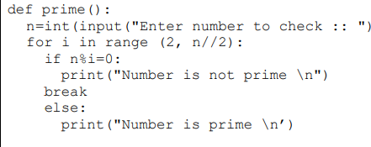
- Predict the output of the Python code given below:
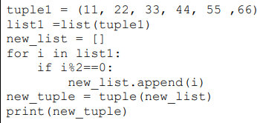
- (a) Given is a Python string declaration: myexam="@@CBSE Examination 2022@@" Write the output of: print(myexam[::-2])
(b) Write the output of the code given below: my_dict = {"name": "Aman", "age": 26}
my_dict['age'] = 27
my_dict['address'] = "Delhi" print(my_dict.items())
- Predict the output of the Python code given below:
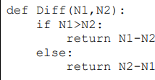

SECTION C-3 Marks(26-30)
- Predict the output of the Python code given below:
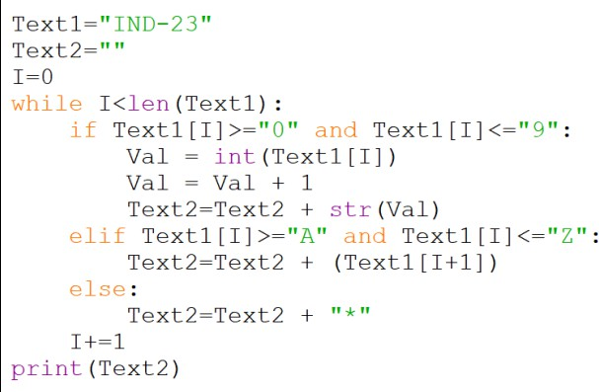
- Write a function in Python to read a text file, Alpha.txt and displays those lines which begin with the word ‘You’.
OR
Write a function, vowelCount() in Python that counts and displays the number of vowels in the text file named Poem.txt.
- Write a function ETCount() in Python, which should read each character of a text file “TESTFILE.TXT” and
then count and display the count of occurrence of alphabets E and T individually (including small cases e and t too).
Example:

If the file content is as follows:
Today is a pleasant day. It might rain today.
It is mentioned on weather sites
The ETCount() function should display the output as: E or e: 6
T or t : 9
- Write a function INDEX_LIST(L), where L is the list of elements passed
as argument to the function. The function returns
another list named ‘indexList’ that stores the indices of all Non-Zero Elements of L.
For example:
If L contains [12,4,0,11,0,56]
The indexList will have - [0,1,3,5
- A list contains following record of a customer: [Customer_name, Phone_number, City]
Write the following user defined functions to perform given operations on the stack named ‘status’:
  - Push_element() - To Push an object containing name and Phone number of customers who live in Goa to the stack

  - Pop_element() - To Pop the objects from the stack anddisplay them. Also, display “Stack Empty” when
there are no elements in the stack. For example:
If the lists of customer details are: [“Gurdas”, “99999999999”,”Goa”]
[“Julee”, “8888888888”,”Mumbai”]
[“Murugan”,”77777777777”,”Cochin”] [“Ashmit”, “1010101010”,”Goa”]
The stack should contain [“Ashmit”,”1010101010”]
[“Gurdas”,”9999999999”]
The output should be:
[“Ashmit”,”1010101010”]
[“Gurdas”,”9999999999”]
Stack Empty
SECTION D- 4 marks each (31-32)

31. (a) Write the output of the code given below:
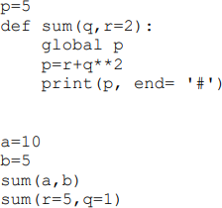
b. Write a program to count number of “in” (any case) in a text file.
- What is the advantage of using a csv file for permanent storage?
Write a Program in Python that defines and calls the following user defined functions:
  - ADD() – To accept and add data of an employee to a CSV file ‘record.csv’. Each record consists of a list with field elements as empid, name and mobile to store employee id, employee name and employee salary respectively.
  - COUNTR() – To count the number of records present in the CSV
file named ‘record.csv’. OR
Give any one point of difference between a binary file and a csv file.

Write a Program in Python that defines and calls the following user defined functions:
- add() – To accept and add data of an employee to a CSV file ‘furdata.csv’. Each record consists of a list with field elements as fid, fname and fprice to store
furniture id, furniture name and furniture price respectively.
- search()- To display the records of the furniture whose price is more than 10000.
SECTION E -5 marks each(33-35)
- (i) Differentiate between r+ and w+ file modes in Python.
(ii) Consider a file, SPORT.DAT, containing records of the following
structure:
[SportName, TeamName, No_Players]
Write a function, copyData(), that reads contents from the file SPORT.DAT and copies the records with Sport name as “Basket Ball” to the file named BASKET.DAT.
The function should return the total number of records copied to the file BASKET.DAT.
OR
(i) How are text files different from binary files?

(ii) A Binary file, CINEMA.DAT has the following structure:
{MNO:[MNAME, MTYPE]}
Where
MNO – Movie Number MNAME – Movie Name MTYPE is Movie Type
Write a user defined function, findType(mtype), that accepts mtype. as parameter and displays all the
records from the binary file CINEMA.DAT, that have the value of Movie Type as mtype.

- Aman is a Python programmer. He has written a code and created a binary file record.dat with employeeid, ename and salary. The file contains 10 records.
He now has to update a record based on the employee id entered by the user and update the salary. The updated record is then to be written in the file temp.dat. The records which are not to be updated also have to be written to the file temp.dat. If the
employee id is not found, an appropriate message should to be displayed.

As a Python expert, help him to complete the following code based on the requirement given above:

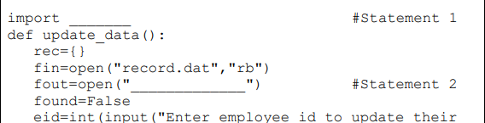
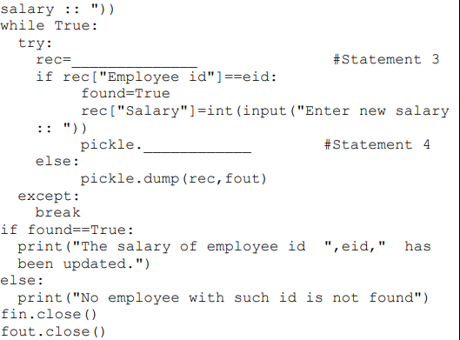

  - Which module should be imported in the program? (Statement1)
  - Write the correct statement required to open a temporary file named temp.dat. (Statement 2)
  - Which statement should Aman fill in Statement 3 to read the data from the binary file, record.dat and in Statement 4 to write the updated data in the file, temp.dat?

- A binary file “Book.dat” has structure [BookNo, Book_Name, Author, Price].
- Write a user defined function CreateFile() to input data for a record and add to Book.dat .
- Write a function CountRec(Author) in Python which accepts the Author name as parameter and count and return number of books by the given Author are stored in the binary file
“Book.dat”

OR
A binary file “STUDENT.DAT” has structure (admission_number, Name,
Percentage). Write a function countrec() in Python that would read contents of the file “STUDENT.DAT” and
display the details of those students whose
percentage is above 75. Also display number of students scoring above 75%.

