ANNUAL EXAMINATION 2024-25
ALL SAINTS PUBLIC SCHOOL
SOCIAL STUDIES
Class : 7
Marks : 60
- MCQ ( 10 Marks )
  - The new castes emerging within Varnas were called
( Gotras, Clans, Jatis)
  - Shankara was an advocate of
( Nirvana, Dharmma, Adwaitha)
  - Generally the warm ocean currents originate near
( Poles, Equator, None of These)
  - Toucans are a type of
( Birds, Animals, Crops)
  - Bengal tiger is found in
( Mountain, Delta area, Amazon)
  - Sahara is what type of desert?
( cold, hot, mild)
  - …is the classical dance form of Tamilnadu
( Kathakali, Bharatanatyam, Odissi)
  - When someone forcefully break the law or a rule
( Violation, harassment, Discrimination )
  - The Powers that government has to disallow media from publishing or showing certain stories.
( Broadcast, Censorship, Publish)
  - The arrangement between the merchant and the weavers is an example of…
( Profit, Exporter, Putting out system )
- MATCH THE FOLLOWING ( 6 Marks )
11) Anantavarman a)Kerala
12) Jagananatha b) Bengal
13) Mahodayapuram c) Orissa
14) Lilatilakam d) Kangra
15) Mangalakavya e) Puri
16) Miniature f) Kerala
III )
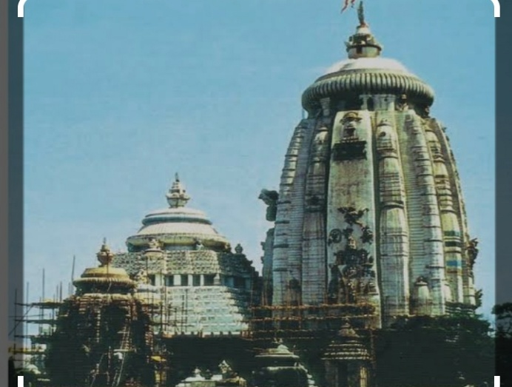
17) Identity the following image shown below and write the name of the historical monument. ( 2 Marks)

Iv)NAME THE FOLLOWING ( 7 Marks )
18) Worlds largest desert.
19) The continent in which the Amazon Basin is located.
20)Streams of water moving along definite paths.
21)House of rest for travelers
22) Writing of Saints lives known as
23) A person who sells goods abroad.
24) When a large number of people come together and openly state their Opposition to some issue.
V) TRUE OR FALSE ( Marks : 5)
25) Nadir Shah invaded Bengal
26) Tribal societies had rich oral traditions.
27) Deserts are characterized by scanty vegetation.
28) In a democracy, the media plays a very important role in providing news.
29) Guru Gobind Singh was the tenth Guru of the Sikhs.
VI ) SHORT ANSWER QUESTION ( any six ) 12 marks
30) In what ways does the media play an important role in a democracy?
31) Describe the beliefs and practices of the Nathpanthis, Siddhas and Yogis.
32) What is Manipravalam? Name a book written in that language.
33) How were the Sikhs organised in the eighteenth century?
34) What type of clothes the people of the Sahara desert wear?
35) What are the major cities located on the River Ganga?
36) What is water cycle?
37) Give reason
People of the Sahara desert wear heavy robes.
38) Define , Ginning Mill
VII ) Long answer questions ( any 5 ) Marks : 15
39) Why did the Marathas want to expand beyond the Deccan?
40) Why were temples built in Bengal?
41) What were the major ideas expressed by Kabir? How did he express these?
42) Define
Publish, Broadcast,
43) What are the climatic conditions of the Ladakh desert? What mainly attracts tourists to Ladakh?
44)What are the factors affecting the height of the waves?
45)Why dis minstrels proclaim the achievements of heroes?
46) Do you think merchants and bankers today have the kind of influence they had in the 18th century.
VIII ) SOURCE BASED QUESTIONS ( 3 marks )
Read the following passage carefully and answer the following questions

A tsunami is a series of large ocean waves generated by significant disturbances in or near a body of water, such as earthquakes, volcanic eruptions, or underwater landslides. Unlike regular ocean waves caused by wind, tsunamis involve the movement of large volumes of water across vast distances. The waves can travel at speeds of up to 500-800 km/h (310-500 mph) in deep water, and when they approach shallow coastal areas, they slow down, increase in height, and become highly destructive.

The Impact of a tsunami can be catastrophic, causing widespread flooding, property damage, and loss of life, particularly along coastal regions. Tsunamis often occur without warning, but modern monitoring systems and early detection methods aim to provide advance notice to affected areas, improving the chances of evacuation and minimizing casualties.
46) Define Tsunami.
47) What are the impact of Tsunami?

