ALL SAINTS PUBLISCHOOL,CHAYAM
ANNUAL EXAMINATION [2024-25] CLASS:4
INFORMATION TECHNOLOGY Marks:60

I. CHOOSE THE CORRECT ANSWER FROM THE BRACKET. (5x1=5)
[ previous, Algorithms , Tabs ,forever ,Rounded rectangle ]
- Home and insert are examples of _________.
- __________ is written in simple English language.
- The _________ block is used to repeat the commands again and again.
- Sanjay presses the Up arrow key to move to the _______ slide of a presentation.
- The _________ symbol is used to represent start in a flowchart.
II. IDENTIFY THE FOLLOWING PICTURES AND WRITE THE NAMES. (5x1=5)
- 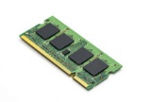
- 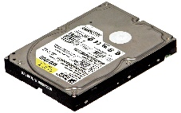
This Photo by Unknown Author is licensed under CC BY-SA
- 
- 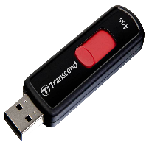
This Photo by Unknown Author is licensed under CC BY-NC
- 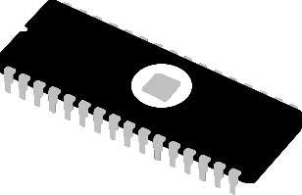
This Photo by Unknown Author is licensed under CC BY
III. WRITE TRUE OR FALSE FOR THE FOLLOWING. (5x1=5)

- You can only use one sprite at a time.
- Facebook is a paid social networking website.
- E-learning is a course which is done online.
- Computer programs are written in programming language.
- Status bar displays the displays the document name and the program name.
IV. FILL IN THE BLANKS FOR THE FOLLOWING. (6x1=6)
- The online diary of a person is known as a _______.
- ________are used to connect the different symbols of the flowchart.
- To start the slide show from the beginning, press the _______ key.
- A copy of the mail you send is saved in the _______.
- Every character in the scratch is called a __________.
- MS power point is a software used to create _________.
V. MATCH THE FOLLOWING . (5x1=5)

22. Pen up - Sound block
23. Forever - pen block
24. Say Hello- Motion block
25. Play sound- Looks block
26. Go to x: 150 y:50 – control block
VI. ANSWER IN ONE WORD. (5x1=5)
27. The loop which runs again and again. ___________________
28. Symbol is used to display output. ______________________
29. Steps are repeated until the condition is met. _____________
30. This key is used to stop the slide show. _________________
31. The place where you can create new sprites. ______________
VII. TWO MARK QUESTIONS. (5x2=10)

32. What is E- shopping?
33. What is a slide?
34. What is flow chart?
35. What is a sprite?
36. What is a slide show?
VIII. THREE MARK QUESTIONS WRITE ANY THREE ONLY . (3x3=9)
37. What is a decision box used for?
38. How is a new slide inserted?
39. What are flow lines?
40. What is a stack of block?
41. What is the use of an algorithm?
IX. WRITE THE FIVE MARK QUESTIONS ANY TWO. (5x2=10)

42. Draw a flowchart to add two numbers.
43. What is a Theme? How do you apply it?
44. What is a broad band connection? What are its requirements?
45. What is E -mail? What are its advantages?

