ALL SAINTS PUBLIC SCHOOL
ANNUAL EXAMINATION 2024-25

SUB:MATHEMATICS
STD : II
MARKS:60

I.FILL IN THE BLANKS (5)

a. 4 × 6 =
b. 10 × 0 =
c. 5 × 100 =
d. ______ is the standard unit of capacity .
e. A square has ____ sides.

II. MATCH THE FOLLOWING (5)

- Cylinder - birthday cap

- Cube - ball

- Cone - dice

- Cuboid - water bottle

- Sphere - book

III. WRITE TRUE OR FALSE (5)

- The first month of the year is March

- Christmas is celebrated on 25 December.

- Standard unit of weight is Litre.

- There are 7 days in a week.

- Children’s day is on 14 November.

IV. Which unit will you use for the following measurements? Pick up the correct option from the list below and write it in the blank space. (5)

{ millilitres , centimetres , gram , Litre , kilograms }

- Length of a shoe lace –

- Weight of a peanut -

- Capacity of a swimming pool –

- Weight of a TV -

- Capacity of a ink bottle -

V. FILL IN THE BLANKS CONSIDERING TODAY IS WEDNESDAY (2)

- Tomorrow will be ________

- Yesterday was ______

VI. WRITE IN WORDS (2)

- ₹ 50.14-

- ₹ 95.20-

VII. WRITE IN FIGURES (2)

- Seventy one rupees twenty one paise -

- Ten rupees twenty paise -

VII. Write 12 months in a year (4)

VIII. SOLVE THE FOLLOWING (3)

- 125 × 3

- 204 × 2

- 112 × 6

IX. COMPLETE THE PATTERNS (5)

  - 2 , 4 , 6 , 8 , ___ , ___

  - 4 , 8 , 12 , 16 , ____ , _____

  - aA , bB , cC , dD , ___ , ____

  - 80 , 70 , 60 , 50 , ____ , ____

  - 1Z , 2Y , 3X , 4W , ____ , ____

X. Write whether the following objects roll, slide or both (2)

- Rubix cube -

- Pencil box –

- Gas cylinder –

XI. Count the shapes (5)

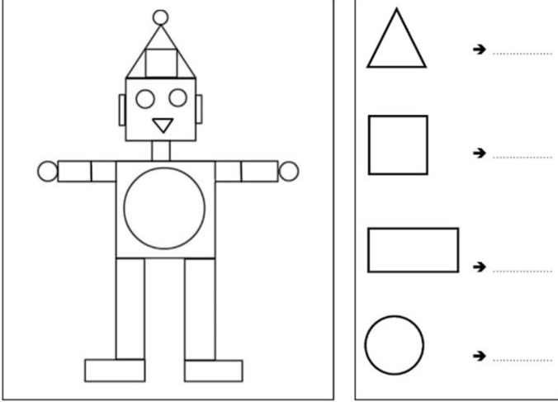

XII. Identify shadows (5)

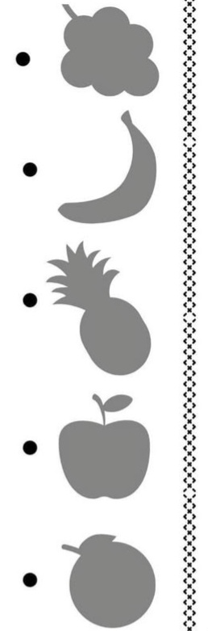

XIII. Label the given time on the clock (4)

a. 4:30
b. 4:45

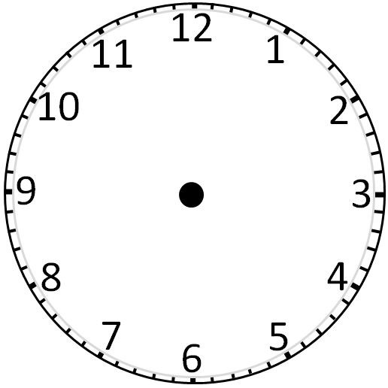

XIV. Analyse data (2)

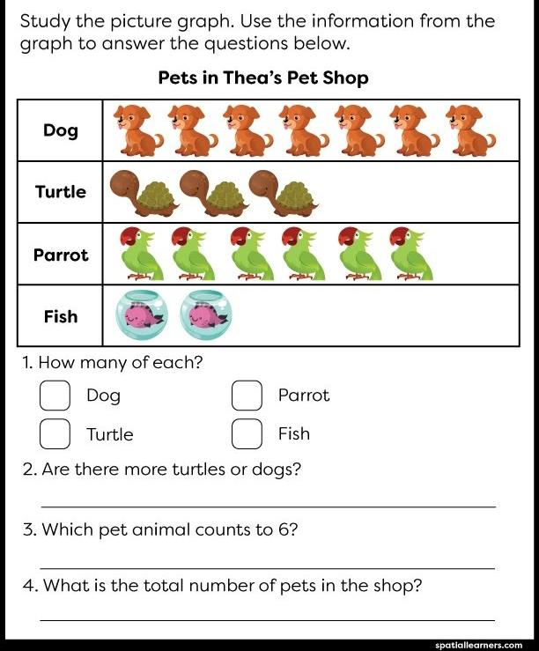

XV. SOLVE THE WORD PROBLEMS (4)

- There are 20 beads in a chain. There are 2 such chains , How many beads are there in all?

b) There are 5 pencils in a box. If there are 5 such boxes, how many pencils are there in all?

