All Saints Public School, Chayam
Class: I IT Marks: 60
Fill in the blanks using correct to options from the bracket. (12) 1.A ---------- is a machine.
( Computer Table )
2. ------- is a drawing program.
( Undo , Tux paint )
3.The ------- tool is selected to draw and filll colour.
( Line , Paint )
4.The ------- tool helps in giving different effects to the drawing
( Magic , Stamp )
5. The hard disk is kept inside the --------
( CPU Box , File. )
6. A ----- can be carried in our pocket.
( Register , Pen drive )
- Match the following. (6)
7. Stamp tool -- Triangle
8. Magic tool -- Mirror
9. Text -- Flip
10. Line tool -- Rain
11. Invert -- Italic
12. Shapes -- Lines
III.Write True or False (6)
13. The text cannot be increased or decreased in size.
14.You cannot store data in a pen drive.
15. Clothes are kept in the refrigerator.
16. Machines make your work easy.
17. A smart phone has touch screen.
18. The name of the penguin in Tux Paint is Tux.
IV. Find out the missing letters and complete the words.(10)
19.a) DA --- A
b) G – A S –
c) T –
d) SA – E
e) F – LE
V. Identify the following features and write their names. (10)
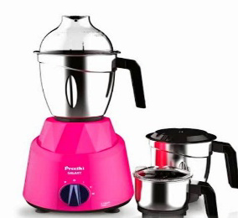
20.a.
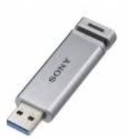
b.

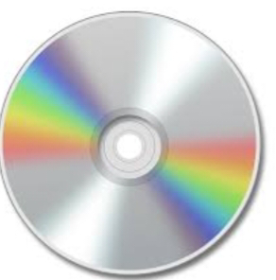
c

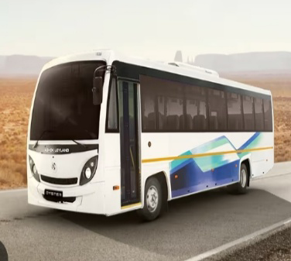
d .


e.

VI.Name the following.(8)
21 a.Write àny two Magic effects.
b.Name any two data storage devices. c.Name any two machines.
d.Name two man made things.
VII.Answer the following.(8)
22.What is tux paint?
23.What is the use of mirror button?
24.Name two parts of computer that help you give data to the computer.
25.Write any two parts of the Tux Window.

