ALL SAINTS PUBLIC SCHOOL
ANNUAL EXAMINATION 2023-24

STD:I
SUB: SCIENCE
MARKS: 60

- TICK THE CORRECT ANSWER (2)

  - Before eating we should
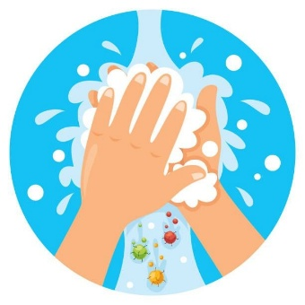



2. In summer, we like to drink this.

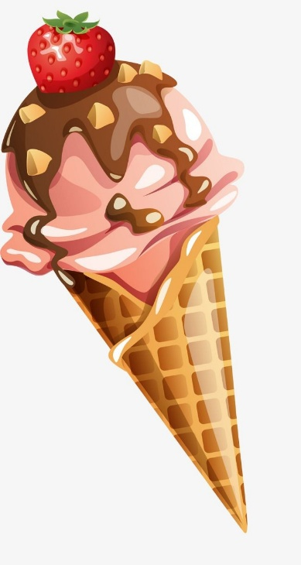
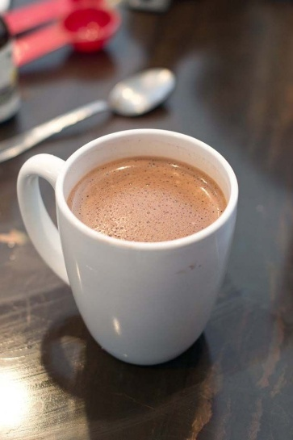

- Circle the pictures in which air is needed. (2×3=6)



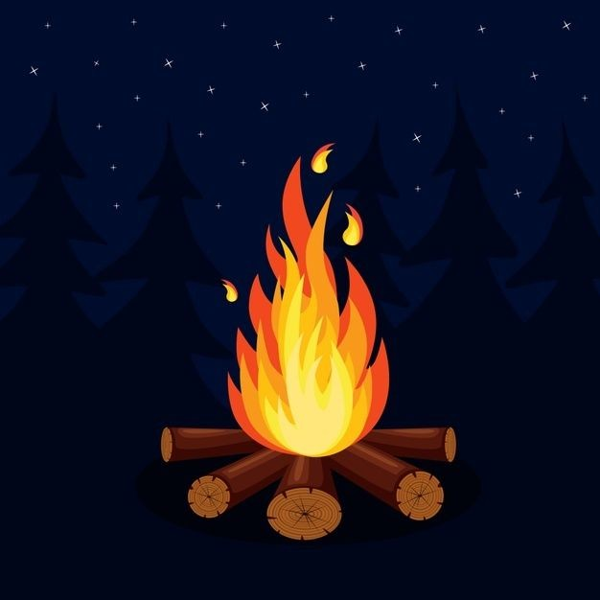

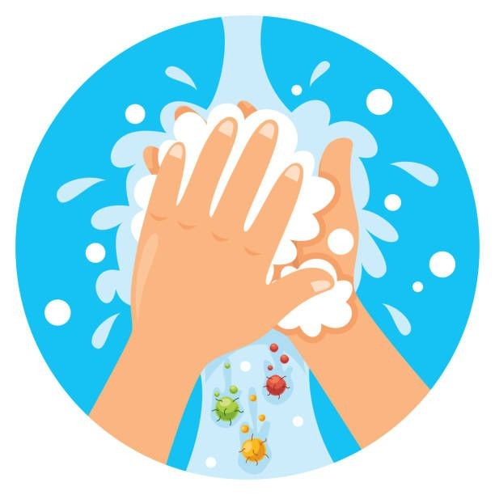



- Circle the activities that can be done only with water (3×3=6)

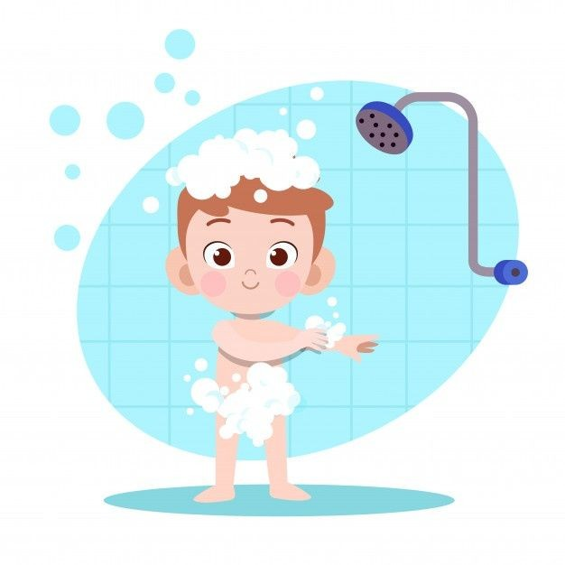


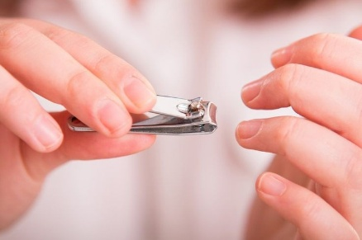
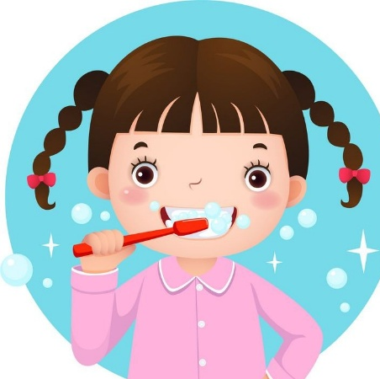

- CIRCLE THE CORRECT ANSWER (1.5×4=6)

1.It is very (hot / cold)in winter.
2. It is very ( hot / cold) in summer.
3.We wear ( uniform / raincoat ) on a rainy day.
4. We wear ( cotton / woollen )clothes in summer.

- FILL IN THE BLANKS (1.5×6=9)

1.The sun gives us ____ (light , water )
2. The sun rises from the ____ ( east , west )
3. We use this on a rainy day ( book, umbrella )
4. A spaceman wears _______ ( spacesuit , raincoat )
5. Summer days are ___ ( cold / hot)
6. At night, we can see ____ (sun / moon)

- WRITE T FOR TRUE AND F FOR FALSE ( 1.5×6=9)
1.We can see stars during night.

2. Filtering helps to purify water

3.We cannot feel air.

4.We cannot live without water.

5. Winter days are cold.

6. You would go into space in a car.

- MATCH THE FOLLOWING (6)

    - Summer days are - rainy

    - Monsoon days are - hot

    - Rocket travels - boiled water

    - Always drink - heat

    - Sun gives us - very fast

- ANSWER THE FOLLOWING (10)

1.write two uses of water.

2. Why do we need air?

3.What must we wear to go out in the rain?

4. When do we see stars?

5. Who was the first Indian to go into space?

- CIRCLE THE CORRECT OPTION (6)



