ALL SAINTS PUBLIC SCHOOL CHAYAM VITHURA
ANNUAL EXAMINATION 2024-2025
GENERAL AWARENESS
NAME :- _______________________ CLASS:-UKG
1.Name the following. (8marks)
a. Two food items that we get from plants.
b. Two food items that we get from animals.
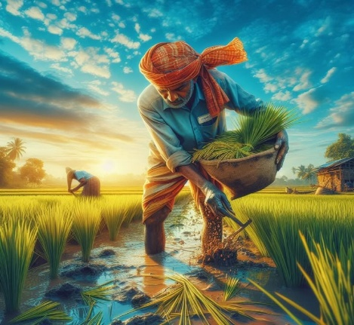

2.Identify the people who help us. (4marks)
________________ ___________________
3.In summer season we feel _____________(hot/cold) (5 marks)

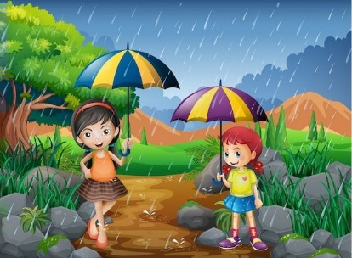
4.Identify the season and name it. (4 marks)
_____________________________
5.which are the colours in a traffic light. (6 marks)
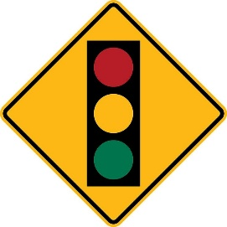
______________________________________
6.Identify the vehicle and write their names from the bracket.(8 Marks )
(Aeroplane, ship, scooter, train)


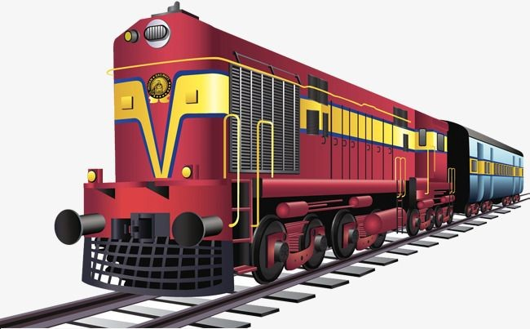
___________________ ____________________
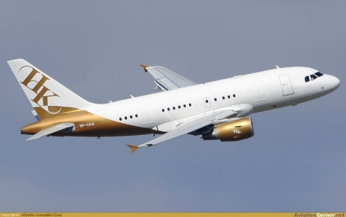
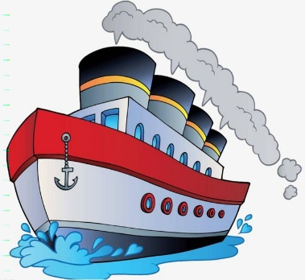
_________________ ___________________
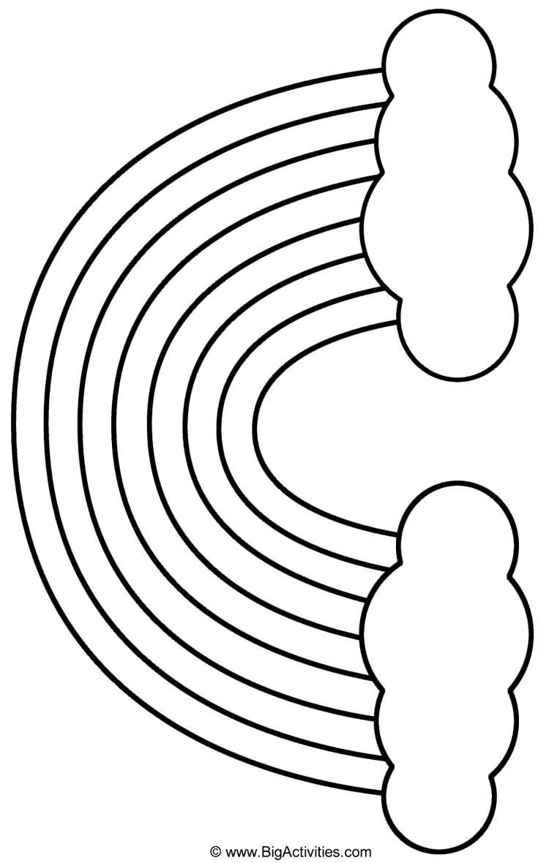
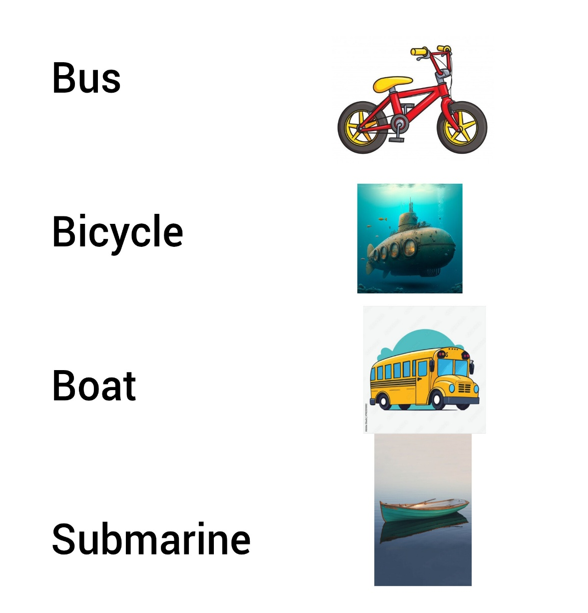
7.Match the following. (8 marks)
8.Colour the rainbow. (7 marks)

