ALL SAINTS PUBLIC SCHOOL CHAYAM VITHURA
ANNUAL EXAMINATION 2024-2025
ENGLISH
Name:-______________ class:-______
1.Circle the ‘ot’ family words (6)

Pot cut run
Rug dot cub
Hot tub fun

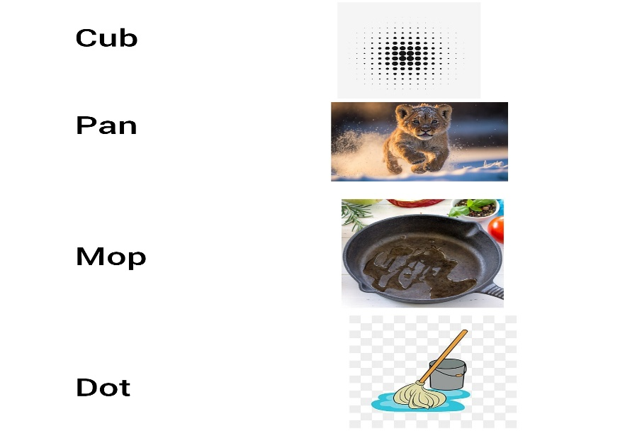
2. Match the pictures to the words (8)
3. Look at the pictures and write their names(10)
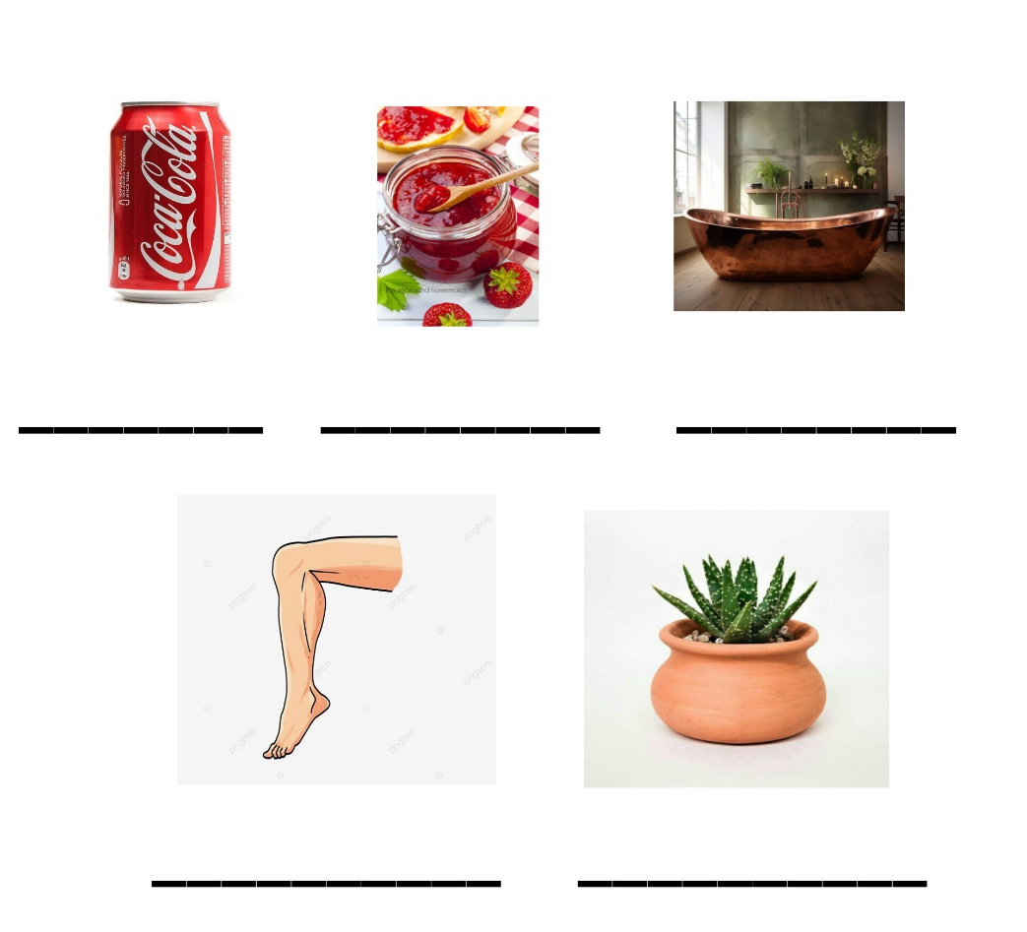

4.Circle the rhyming words(5)

Run bun mat

Fog gun cat

Got nun car

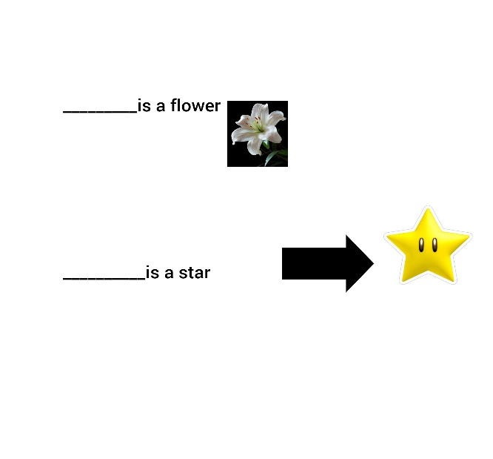
5 Use this or that(4)

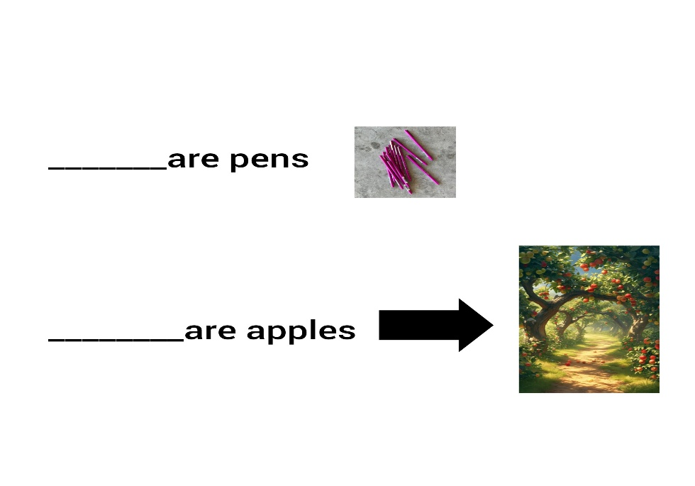
6 Look at the pictures and complete the sentences, These or Those(

7. Write the opposites. (10)
In ×____________
Hot×___________
Happy×________
Open×_________
Sweet×_________
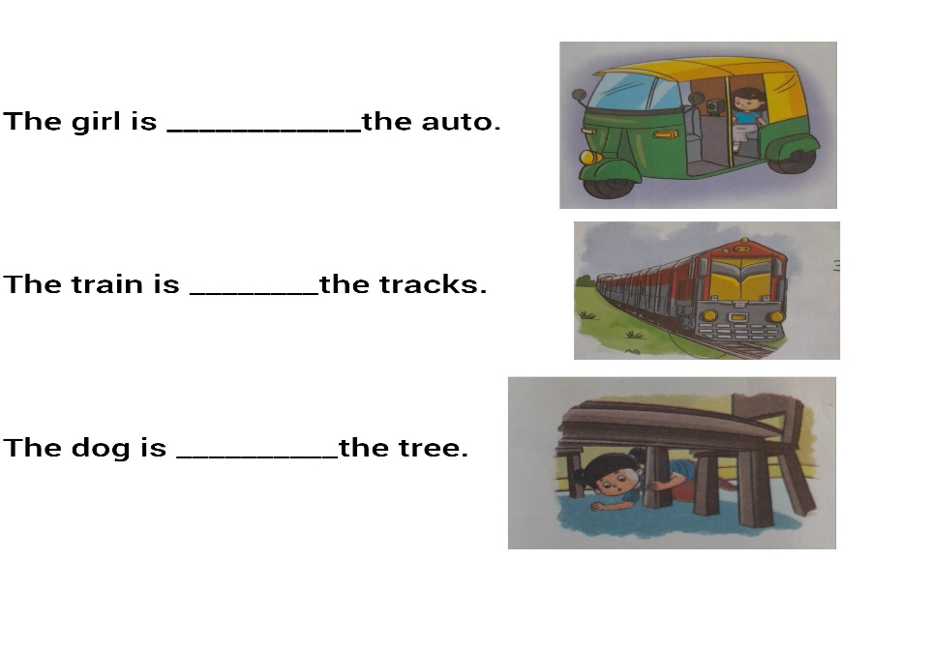
8.Use in, on, under (3)

