ALL SAINTS PUBLIC SCHOOL CHAYAM
ANNUAL EXAMINATION 2024-2025
ENGLISH
NAME:- ____________ CLASS:-_______

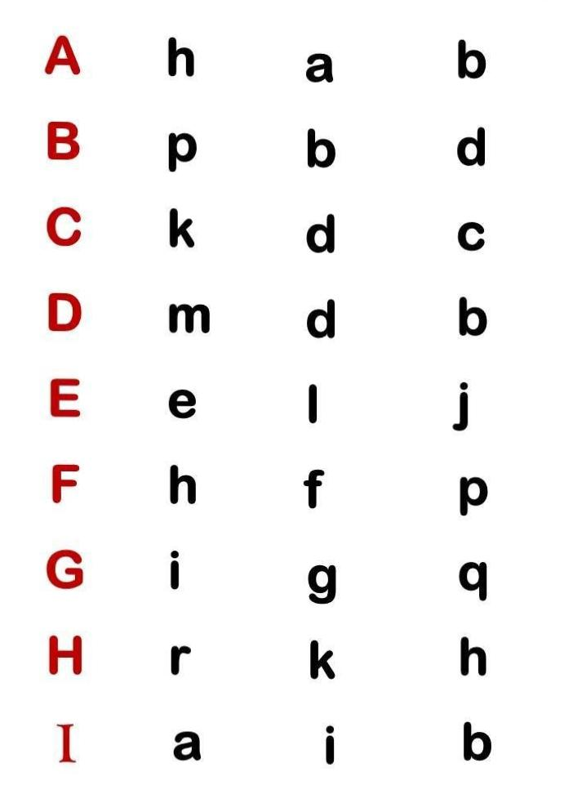
1.Circle the capital letter with the small letter. (8)
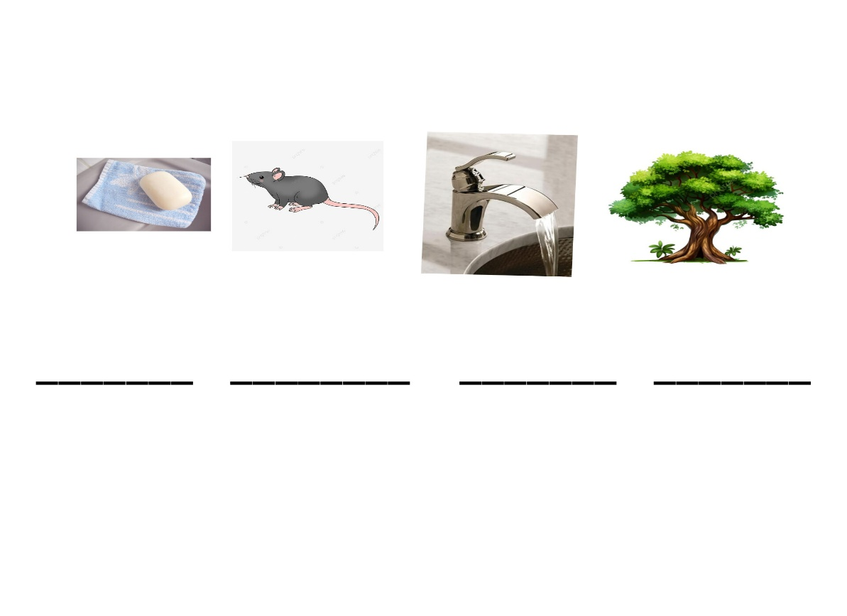
2.Write the first letter of the following.(8)

3.Underline or circle the letter V in the below rhyme.(6)

V is for the Van that goes ‘Vroom!’Vroom!
V is for the Vase that’s in my room
V is for the Violin that plays a tune
V is for the violets that grows and bloom.

4.fill in the missing letters. (12)

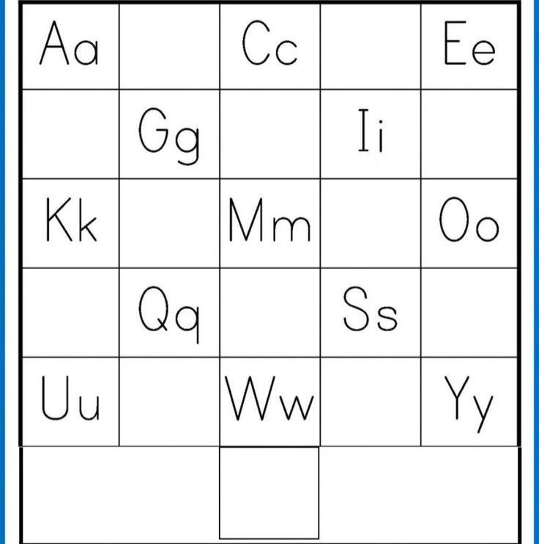

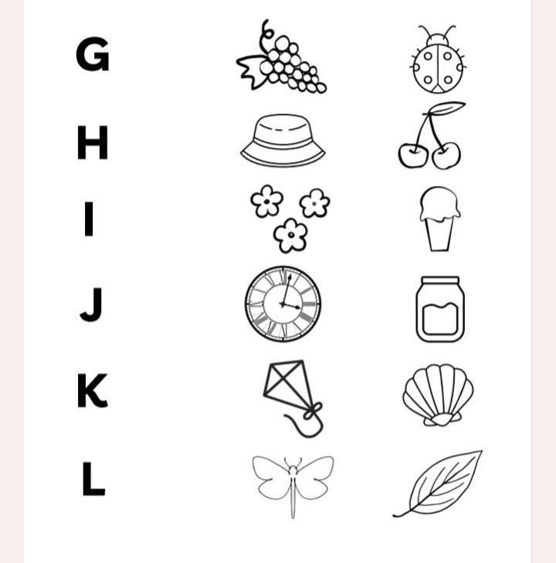
5.Colour the correct picture (6)

6.write the first letter for the following words. (10)


