GEOGRAPHY (029)
Class: XII: 2024 – 25
Time allowed: 3 Hours Maximum marks: 70
General Instructions:
Read the following instructions carefully and follow them:
- This questions paper contains 30 questions. All questions are compulsory.
- Question paper is divided into five sections A, B, C, D and E.
- Section A Questions no. 1 to 17 are Multiple Choice type questions. Each question carries 1 mark.
- Section B Questions no. 18 and 19 are Source-based questions. Each question carries 3 marks.
- Section C Questions no. 20 to 23 are Short Answer type questions. Each question carries 3 marks. Answer to these questions shall be written in 80 to 100 words.
- Section D Questions no. 24 to 28 are Long Answer type questions. Each question carries 5 marks. Answer to these questions shall be written in 120 to 150 words.
- Section E Questions no. 29 and 30 are Map-based questions. Each question carries 5 marks.
- In addition to this, NOTE that a separate question has been provided for Visually Impaired candidates in lieu of questions having visual inputs, map etc. Such questions are to be attempted by Visually Impaired candidates only.
- There is no overall choice given in the question paper. However, an internal choice has been provided in a few questions in all sections other than Section A.
Section A
Questions no. 1 to 17 are Multiple Choice Type Questions. (17X1) 17
- Which of the following geographer who introduced the concept of Neo determinism? 1
        - Ratzel
        - Paul Vidal de la Blache.
        - Ellen C Semple.
        - Griffith Taylor.
- Which one of the following continents has the highest growth of
population? 1
        - South America
        - Africa
        - Asia
        - North America
- Which one of the following is not a key area in human development? 1
- Access to resources
- Long and healthy life
- Economic disadvantage
- Education
- Which of the following pair is correct? 1
- Mixed farming: paddy dominated cultivation
- Primitive-Subsistence of agriculture: Mechanized grain farming
- Intensive-Subsistence of Agriculture Jhuming farming
- Mediterranean Agriculture: Production of citrus fruits
- Which of the following states as the lowest urbanization in India as per 2011 census? 1
- Jharkhand
- Himachal Pradesh
- Bihar
- Assam
- Choose the characteristics of clustered settlements. 1
- Mainly found in Himachal Pradesh
- Mainly found in lower valleys of Himalayas
- Mainly found in Rajasthan
- mainly found in fertile alluvial plains
- Which type of rural settlements are largely found in Gujarat plains and in some parts of Rajasthan. 1
- Semi clustered Settlements
- Clustered Settlements
- Hamleted Settlements
- Dispersed Settlements
- The physical extent of land on which crops are sown and harvested is known as. 1
- Forest
- Culturable wasteland
- Launch put to on agricultural uses
- Net sown area
- Considering the following statement. 1
- Khariff crops are grown after onset of monsoon
- Kharif crops are harvested in the month of April may
  - (i) Only
  - (ii) Only
  - Both (i) and (ii)
  - Neither (i) or (ii)
- Which of the following is not true regarding Indira Gandhi canal? 1
- It was previously known as Rajasthan canal
- it originates at Harika barrage in Punjab
- The canal runs almost parallel to Pakistan border
- Rajasthan is the least benefited by this canal
- In Which state “Neeru-meeru” programme has been taken up for water harvesting. 1
- Madhya Pradesh
- Tripura
- Andhra Pradesh
- Rajasthan
- Which one of the following states is the largest producer of mica in India? 1
- Gujarat
- Chattisgarh
- Bihar
- Jharkhand
- Name the largest producer of petroleum in India. 1
- Bassien
- Mumbai High
- Numalisgarh
- Jharkhand
- Consider the following statement 1
Assertion (A): Industries maximize profit by reducing costs.
Reason (R): Therefore, industries should be located at point where the product costs are minimum.
  - Both A and R is true and R is the correct explanation of A
  - Both A and R is true and R is the correct explanation of A
  - A is true but R is false
  - A is false but R is true
- Choose the features of open cost mining from the following. 1
- Cheapest way of mining
- It requires lift drills
- It requested ventilation system
- It has a high Labour Cost
- What are the indicators of HDI? 1
- Longevity
- educational attainment
- Standard of living
- All of the above
- The density of population is usually expressed in terms of: 1
  - Person/cm area
  - Person/sq km area
  - Person/cubic area
  - All of the above
Section B
Question number 18 and 19 are source-based questions. 2x3=6
- Read the given passage and answer the questions that follows 3x1=3
Benda lives in the wilds of the Abujh Maad area of central India. His village consists of three huts Deep in the wilds. Not even birds or stray dogs that usually crowd villages can be seen in these areas. Wearing a small loin cloth And armed with his axe he slowly surveys the Penda(forest) where his tribe practices primitive form of agriculture called shifting cultivation. Benda and his friends burned small patches of forest to clear them for cultivation. The ash is used for making the soul fertile. Benda is happy that the mahua trees around him are in bloom. How lucky I am to be a part of this beautiful universe, he thinks as he looks up to the Mahua, Palash and Sal trees That have shelter him since childhood. Crossing the penta in a gliding motion, Benda makes his way to a stream. As he bends down to scoop up a home full of water, he remembers to thank Loi-Lugi, The spirit of forest for allowing him to quench his thirst. Moving on with his friends, Benda chews succulent leaves and roots. The boys have been trying to collect Gajjhara and Kuchla, From the forest let's jump these are special plants that Benda and his people use. He hopes the spirits of the forest will be kind and lead him to these herbs.These are needed to barter in the Madhai or tribal fair coming up the next full moon. He closes his eyes and tries hard to recall What the elders herbs taught him about these herbs and the places they are found in. He wishes he had listened more carefully. Suddenly there is a rustling of leaves. Benda and his friends know it is the outsiders who have come searching for them in the wilds. In a single fluid motion Benda and his friends disappear behind the thick canopy of trees and become one with the spirit of the forest.
  - Identify the Approach of human geography which is mentioned in the above passage?
  - What is Loi – Lugi?
  - What type of agriculture practice by Benda and his tribe done?
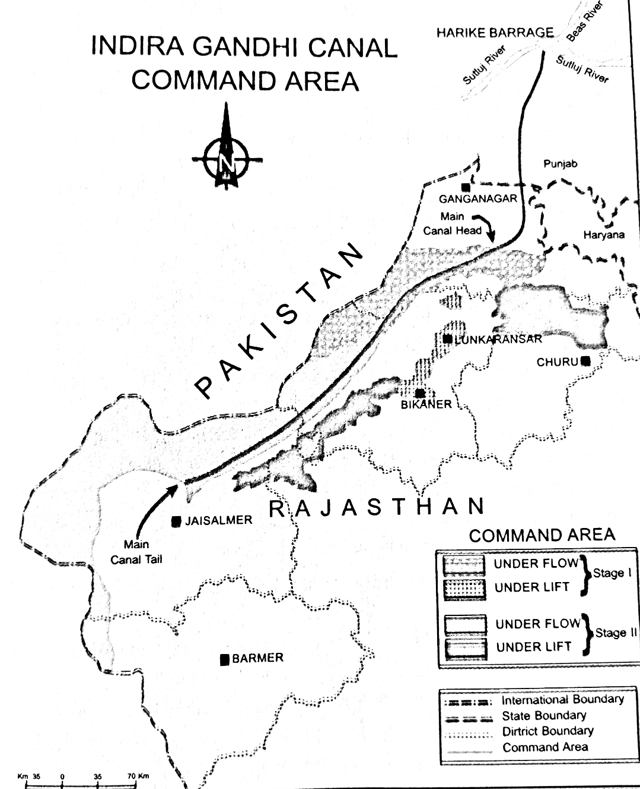
- Observe the given map below and answer the following questions. 3x1=3

19.1 Mention the source of origin of this canal.
19.2 Why is the idea to the east of the canal and lift regulation?
19.3 Explain the economic significance of this canal for the command area.
Section C
Question Number 20 to 23 are short answer type questions 4x3=12

- Explain the concept of possibilism with examples. 3
Or
Give reasons for the high-density population I South, South-East and South Asia.
- What is mining? Name the two types of mining. Give one characteristic of each type. 3
- Which is the working age group? Describe the three characteristics of this age group. 3
- Explain 4 basic differences between rural and urban settlements in India. 3
Or
States any three points regarding the conservation of mineral resources. Stop
Section C
Question Number 24 to 28 are long answer type questions 5x5=25
- Distinguish between plantation agriculture and horticulture 5
Or
Describe four main pillars of human development.
- Analyse the effects of geographical factors on the distribution of world population. 5
- Explain two main features each of the four types of rural settlements found in India. 5
Or
Write down major objectives of rainwater harvesting and mention some low-cost rainwater harvesting techniques.
- Why is the development and utilisation of non-conventional sources of energy becoming increasingly importance? Evaluate your answer with suitable examples. 5
Or
Describe the agricultural techniques which could help to improve the productivity of a cultivator land.
- Describe the national water policy in detail. 5
Or
What are urban settlements? Classify Indian towns into three categories according to urban historians and write the main character people of each category.
Section D

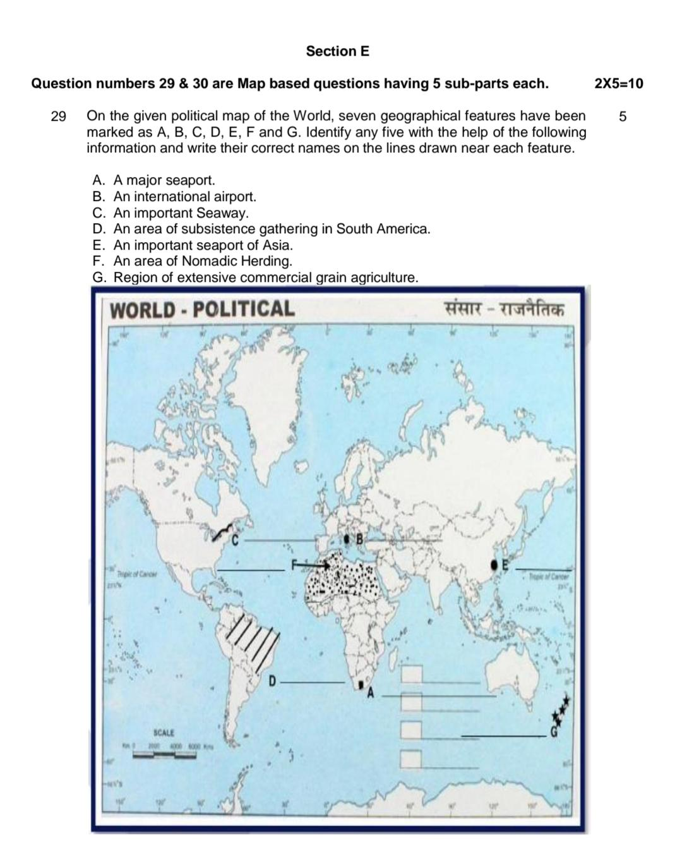

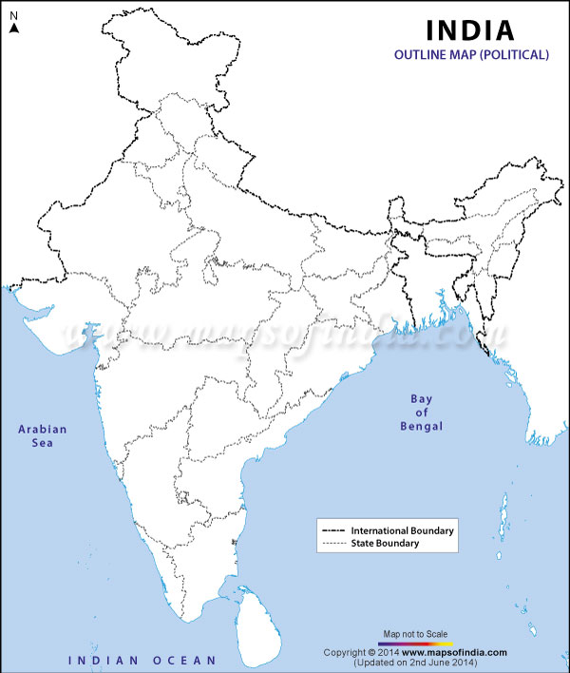
Locate and label any five of the following features in the given outline map of India
  - An important coal mine in Odisha
  - An important seaport in Karnataka
  - Jharia – Coal Mines
  - An oil refinery in Uttar Pradesh
  - The state with lowest population density
  - The state leading in the production of tea.
  - An international Airport in Punjab

