ALL SAINTS PUBLIC SCHOOL, CHAYAM, VITHURA
SA 1 EXAMINATION (2024-25) CLASS-2
INFORMATION TECHNOLOGY Marks- 60
NAME :_________________________________________________ ROLL NO._____ DIV.________

I.FILL IN THE BLANKS. (10x2=20)
1. A wired mouse is connected to -------------------------
2. A ……………….. do big calculations.
3. Writing on a computer using keyboard is called…………………
4. A ------------------ is used to take printouts
5. We can send ------------------- using computers.
6. Computers are used to take out money from ------------------.
7. We------------------------ the work we do on the computer
8. ………………. Is used to record sound.
9. Monitor is also called ---------------------
10.--------------- is fixed inside the CPU.
III. IDENTIFY THE FOLLOWING PLACES AND WRITE THE NAMES. (5X2=10)

11. 
This Photo by Unknown Author is licensed under CC BY-SA

12. 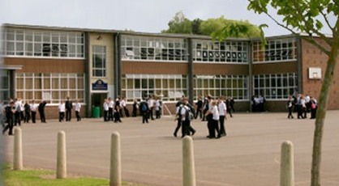
This Photo by Unknown Author is licensed under CC BY-SA

13. 
This Photo by Unknown Author is licensed under CC BY-SA

14. 
This Photo by Unknown Author is licensed under CC BY
15. 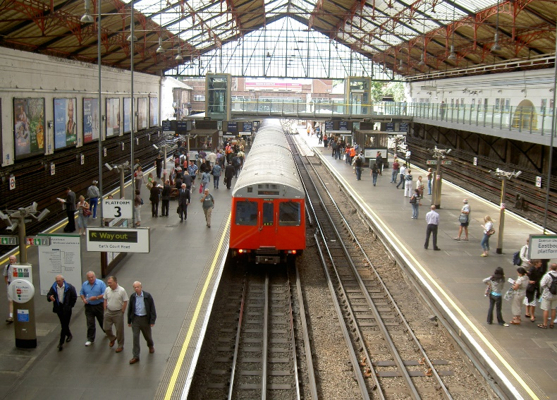
This Photo by Unknown Author is licensed under CC BY-SA

IV. Write YES OR NO for the following statement. (5x1=5)
16. A ball mouse has a laser light under it.
17. To scroll , the index finger is used.
18. Computer need time to finish the work.
19. The full form of CD is cool Disk.
20.Pen drive is also called flash drive.

V. ANSWER IN ONE WORD. (5x1=5)
21. Which key is used to open a shortcut menu?
22. What is called the small blinking line on the screen?
23. Which action is used to draw pictures?
24. What is the printed work called?
25. Name the device that store our work on a computer.

VI. Match the following. (5X1=5)
26. To select an item - scrolling
27. To move the page up and down.- double click
28. To open a shortcut menu -Click
29. To draw a rectangle -right click
30. To open a program -Drag

VII. ANSWER ANY 5 FROM THE FOLLOWING QUESTIONS .

31. What is use of arrow key?
32. What is a cursor?
33. What is the use of the start button?
34. Name any two disadvantages of computer?
35. What is mean by processing?
36. Name the three parts of I-P-O cycle
37. Name two animated movies ?
VIII. WRITE ANY ONE OF THE FOLLOWING. [5 mark)
38. Name the five places were computers are used?
39. Name the five mouse actions?

