ALL SAINTS PUBLIC SCHOOL
SA1 EXAMINATION 2024-25
STD:1 MARKS : 100
SUB: GK

- Choose the correct answer from the bracket [10x2=20 Marks]

- Our national flag has ________________ Colours [ Two, Three]
- Our National Animal ________________ [Tiger, Lion]
- _________ is the baby of a dog [Kid, Puppy]
- _________ gives us heat and light [Clouds, Sun]
- The Sunrises in the ___________ [East , West]
- A helicopter flies in ___________ [road, air]
- _________ is celebrated in honor of king Mahabali [Onam, Holi]
- A game played with a bat and ball is _____________ [Cricket, Football]
- ________ is the festival of colours [Holi, Diwali]
- The elephant is big. The ant is __________ [Small, Tall]

- Match the following [5x2=10 Marks]
  - Water Sight
  - Pine Smell
  - Eyes melon
  - Ears Apple
  - Nose Hear

- Fill in the blanks [2x10=20 marks]
[Lotus, Tiranga , Star, West, Road , Cub, Diwali , Swimming, Tress, Cub]
  - A car runs on _________
  - We twinkle in the sky at night ___________
  - Our national flower is _________
  - The sun sets in the ________
  - Our national flag is called ___________
  - _________ is the baby of a tiger
  - _________ is the festival of light
  - A sports in which you need a pool ________
  - Big plant are called ___________
  - _________ gives us milk

- Write the opposite of the words [5x2=10 Marks]
- Cold x _________
- Heavy x _________
- Short x _________
- Big x ___________
- Fast x __________

- Write the rhyming words [5x2=10 Marks]
  - Hat - ____________
  - Ten - ____________
  - Air - ____________
  - Sing - ____________
  - Can - ____________

- Write true or False [5 Marks]
  - Throw wastes in a dustbin
  - We celebrate independence day on 15th August
  - We should respect our national flag
  - We should not talk while visiting places of worship
  - Christmas is celebrated on the birthday of Jesus Christ.

- Name the following with help of Pictures [5 Marks]
  - __________________________________
  - 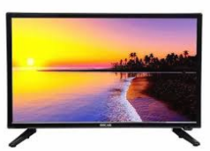___________________________
  -  ____________________________

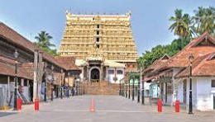____________________________
  - ___________________________

- Write living and non-living things [5 Marks]
  - Lion
  - Bag
  - Girl
  - Plant
  - Pencil
  - Butterfly
  - Cap
  - Cat
  - Car
  - Toys

- Answer the following
  - Write the name of the animal that gives us milk [1 Mark]
  - A vegetable that grow under the ground [1 Mark]
  - Name a doing word [1 mark]
  - Classify the given animals as Domestic and Wild animals [2 Marks]
    - Lion
    - Cow
    - Dog
    - Bear
  - Name five fruits [5 Mark]
  - Name five birds [5 Mark]

