ALL SAINTS PUBLIC SCHOOL
SA1 EXAMINATION 2024-25

STD I
SUB : MATHEMATICS
MARKS : 60
- TICK THE CORRECT ANSWER (1×5=5)

  - The number name of 20 is ___

[ twelve , twenty ]

  - 12 is _____ 10

[ smaller than , larger than ]

  - 4 + 3 = ___

[ 6 , 7 ]

  - 5 - 5 = ___

[ 1 , 0 ]

  - ____ comes just before 24

[ 27 , 23 ]

- WRITE THE NUMBER THAT COMES JUST AFTER. (1×5=5)

a. 7 ⬜️
b. 11 ⬜️
c. 34 ⬜️
d. 16 ⬜️
e. 26 ⬜️

- WRITE THE NUMBER THAT COMES JUST BEFORE (1×5=5)

a. ⬜️ 32
b. ⬜️ 13
c. ⬜️ 25
d. ⬜️ 7
e. ⬜️ 18

- INSERT THE SYMBOL < OR > OR = IN THE BOX ( 1×5=5)

  - 5 ⬜️ 8

  - 12 ⬜️ 19

  - 20 ⬜️ 25

  - 4 ⬜️ 14

  - 18 ⬜️ 26

- MATCH THE FOLLOWING ( 1×5=5 )

  - 3 + 4 - 5

  - 4 + 1 - 4

  - 6 - 1 - 7

  - 10 - 1 - 1

  - 1 + 0 - 9

- WRITE THE MISSING NUMBERS ( 1×5=5)

  - 12 , __ , 14 , 15 , ___

  - 4 , 5 , ___ , 7 , ___

  - 26 , 27 , 28 , 29 , ___

- CIRCLE THE LARGER NUMBER ( 1×3=3)

  - 15 , 20

  - 32 , 36

  - 2 , 7

- CIRCLE THE SMALLER NUMBER (1×2=2)

  - 20 , 10

  - 31 , 38

  - 22 , 30

- ADD AND FILL IN THE BOX ( 1× 2=2)

  - 10 + 4 = ⬜️

  - 4 + 3 = ⬜️

- SUBTRACT AND FILL IN THE BOX ( 1× 2=2)

  - 8 - 4 = ⬜️

  - 10 - 2 = ⬜️

- COUNT THE SHAPES AND WRITE ( 1 × 4 = 4 )

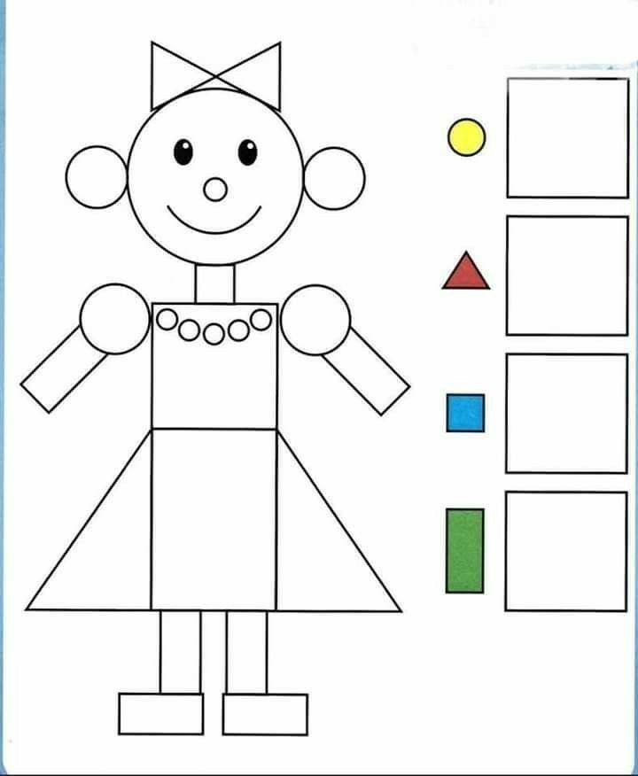
- MATCH THE SHAPES (4)
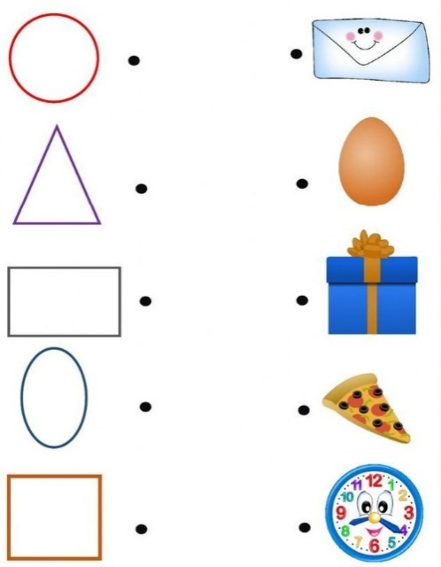

- ADD ON NUMBER STRIP (4)

  - 5 + 3 =

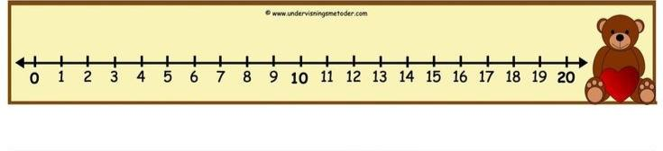

  - 3 + 5 =
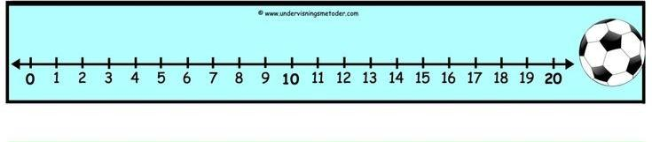

- WRITE R FOR THE OBJECTS THAT ROLL AND S FOR THE OBJECTS THAT SLIDE AND RS FOR THE OBJECTS THAT ROLL AND SLIDE BOTH (5 )






