ALL SAINTS PUBLIC SCHOOL, CHAYAM, VITHURA
SA 1 EXAMINATION (2024-25) CLASS-1
INFORMATION TECHNOLOGY Marks- 60
NAME :_________________________________________________ ROLL NO._____ DIV.________
- TICK THE CORRECT ANSWER FOR THE FOLLOWING [10X2=20]
- Writing on computer is called ----------------. [Typing / moving]
- -------------- is the brain of the computer. [CPU / Mouse]
- -------------- makes our work easy. [ Computer / TV]
- -------------- key is used erase the letter or number. [ Back space /space bar]
- ---------------- is an example of mouse action.[ Click / Monitor]
- The printed work is called -------------. [ Typing / Printouts]
- ------------------ part is used to record sound. [ printer / Microphone]
- ----------------- is look like a TV. [ Monitor/ cpu]
- We can book train or movie ---------------- on a computer. [Tickets/ video]
- A -------------- click our photograph. [CPU/ Camera]

- IDENTIFY THE FOLLOWING PICTURES AND WRITE THE NAMES. (5X2=10)

11.
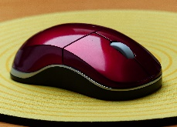--------------------------------------------

12. 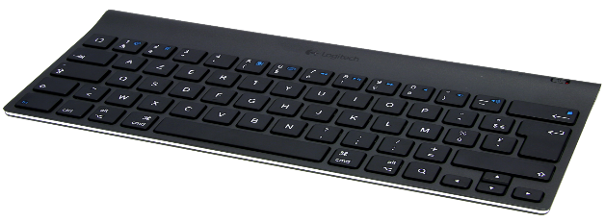-----------------------------------------------
This Photo by Unknown Author is licensed under CC BY-NC
13. 
---------------------------------------------

14. 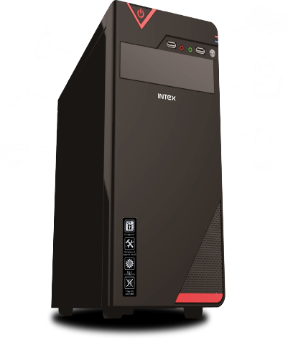----------------------------------------------
This Photo by Unknown Author is licensed under CC BY-NC
15. 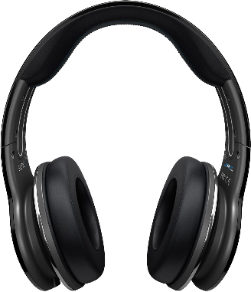---------------------------------------------------------
This Photo by Unknown Author is licensed under CC BY-NC

IV. Write YES OR NO for the following statement. (5x1=5)

16. We use computers at home,. ---------------------------------
17. A computer is a machine. ----------------------------------
18. Enter key is used to type in the next line. -----------------------------
19. A computer has three main parts. -------------------------------
20. We use printer to print our work on a paper. ---------------------------
V. FILL IN THE MISSING LETTERS FOR THE FOLLOWING WORDS. (5x1=5)

21. S------ace bar key
22. Hos-----ital
23. Moni-----or
24. Bac---- space key
25. Sc-----ool

VI. Match the following. (5X1=5)
26. Alphabet key – Give space
27. Number key - type in the next line
28. Space bar key- Type hello
29. Enter key -Select things
30. Click - Type 5

VII. ANSWER THE FOLLOWING QUESTIONS
31. Which key is used type the address?--------------------------------------------------------- [2]
32.Write any one manmade thing? ------------------------------------------------------------------ [2]
33. Write any two part of a computer? ----------------------------------------, -----------------------------------------
34. Which part is used to draw pictures on a computer? ------------------------------------------------------
35. Write the three mouse buttons on a computer. [3]
-----------------------------------------------------
-----------------------------------------------------
-------------------------------------------------------
36. What are the four places where computers used? [4]

----------------------------------------------------------- , ----------------------------------------------------------------
----------------------------------------------------------- , ----------------------------------------------------------------

