All Saints Public School,Chayam
Half Yearly Examination
Class : III Science Marks:60
I.Choose the correct options from the bracket. ( 8 )
1.All food chains begin from -----
( animals , plants )
2. ---------- happen suddenly.
( Accident , Swimming )
3. --------- makes the soil fertile.
( Stone , Humus. )
4. --------- is a natural thing.
( Moon , Bag )
5. ------- is a non – green plant
( Grass. , Mushroom )
6.The food making process of plant is called --------
( Photosynthesis , breathing )
7.Cranes and Herons are -------- birds.
( Wading , Perching. )
8. --------- lay eggs.
( Cat , Hen )
II.Match the following. ( 6 )
9.Leaf blade - Road
10.Bean - Desert
11.Airholes. - Leaf
12.Man- made thing. - Taproot
13.Sandy soil - Insects
14.Footpath. - Bridge
III.Write True or False. ( 6 )
15.Animals get their energy from food
16. Use a sharpener to sharpen pencils
17.Living things cannot grow .
18.The stem grows below the ground.
19.We must be kind to all animals.
20.A frog has long sticky tongue to catch insects.
IV.Circle the odd one. ( 4 )
21.Sun Moon House Water
22.Lion Tiger Rabbit Cheetah
23.Fox Elephant Parrot Tiger
24.Root Flower Leaf Book
V.Read the clues and unscramble the letters to get the names of the parts of a plant (8)
25.a) It grows above the ground
TEMS. -------------------
b)It makes the food for the plant. FEAL -----------
c) Most flowers grow into these RUITSF -----------
d) It grow below the ground.
TORO ----------------
VI. Name the following using correct options from bracket. ( 8 )
26.Animals that chew the cud are mostly
( Carnivores , herbivores)
27.The soil is home to
( birds , insects. )
28.Name one living things
( Car , Plant )
29.Which is the largest living animal ?
( Blue whale , Ostrich )
VII.Classify the followings are Natural or Man – made (6)
30. ( Elephant , Cup , Tree ,
Pencil , Train , Sun , Air , Chair )
VIII.Answer the following.
Answer any four. ( 8 )
31. Name different types of food that omnivores get from animals.
32.Why do we need a house?
33.How do rocks change to soil?
34.What are natural things? Give two examples.
35.Why do animals move from place to place?
IX.Think and answer . (2)
36.If mangoes are eaten in June .When would you see flowers on the mango tree? In February or July?
X . Identify the claws of the birds and write their names using help box. ( 4 )

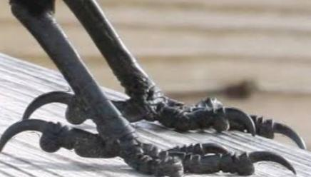

b)
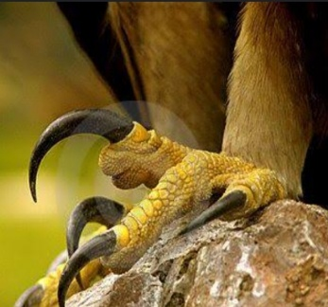

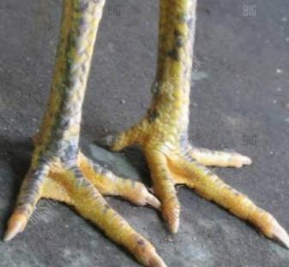
c)

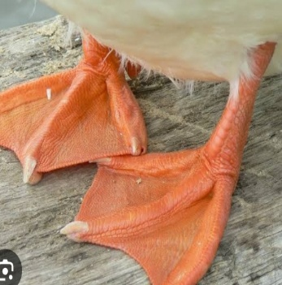
d)

( Duck , Hen , Crow , Eagle )

