ALL SAINTS PUBLIC SCHOOL CHAYAM VITHURA
HALF YEARLY EXAMINATION 2024-25
MATHEMATICS
CLASS 3 MARKS 60
TIME 2HR
- Choose the correct answer. (1×5=5)
  - 3248-3248=----------
( 3248, 0, 1)
  - 234-104=-----------
( 130, 100,30)
  - 64×0=------------
( 64, 0, 1 )
  - 5×3=-------
( 15 , 5, 3 )
  - 63÷1=--------
( 63, 1, 0)
- Match the following (1×5=5)
  - 9×2 14
  - 10×5 63
  - 7×7 18
  - 7×2 50
  - 9×7 49
- Fill in the blanks. (2×2=4)
  - 9×3=27
27÷3=-----
27÷9=-----
  - 4×7=28
28÷4=-------
28÷7=--------
IV . Find the products. (1×6=6)
- 36×10
- 48×10
- 36×100
- 45×100
- 6×1000
- 9×1000
V . Divide ( Do any two questions) (2×2=4)
- 63÷3
- 55÷5
- 69÷3
VI. write the fraction of the shaded part in each picture (2×3=6)
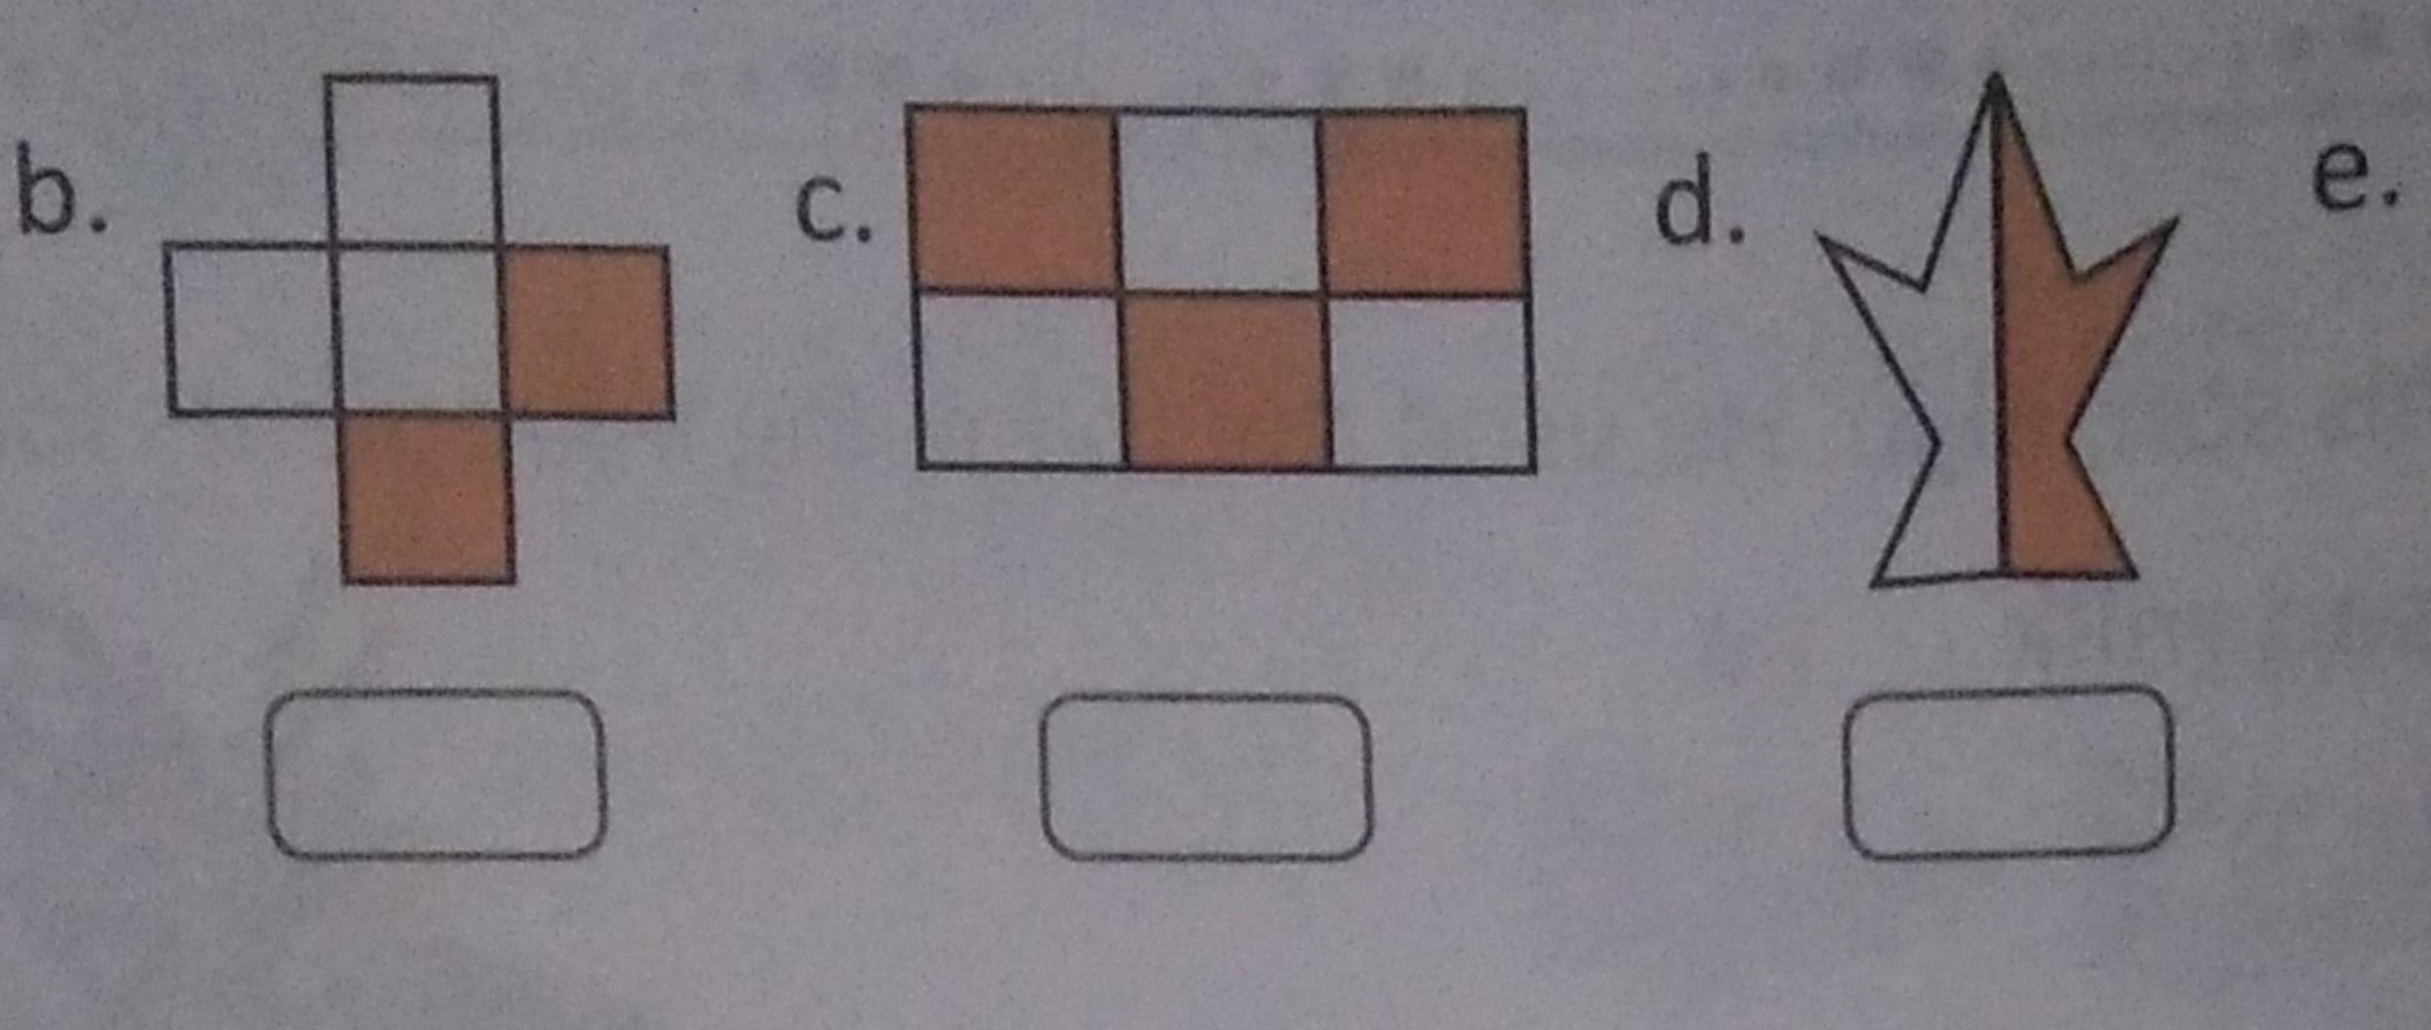
VII. Fill in the blanks. (2×2=4)
- ½ of 12
- 1/3 of 6
VIII. Solve any three questions. (2×4=6)
- 246÷2
- 252÷3
- 372÷6
- 492÷2
- 363÷3
IX. Find the products. ( Do any three questions. )
(2×3=6)
- 112×2
- 121×4
- 333×2
- 413×2
- 211×4
X. Subtract the following (Do any two questions)(2×2=4)
1. 2362-1120
2. 3458-2117
3. 5625-4213
XI. Write the numerator and denominator of the following fractions. (2×3=6)
- 3/8
- 2/4
- 4/9
XII. Word problems. (Do any two questions )
(2×2=4)
- A shop keeper sells 139 cones of chocolate ice creams and 241 cones of strawberry ice creams. What is the total number of ice creams he sold?
- A lorry can carry 326 bicycles in a trip. How many bicycles can the lorry carry in 8 trips?
- 1000 people can sit in an auditorium. How many people can sit in 9 such auditoriums?

