ALL SAINTS PUBLIC SCHOOL, CHAYAM, VITHURA
SA 1 EXAMINATION (2024-25) CLASS-III
INFORMATION TECHNOLOGY Marks- 60
NAME :_________________________________________________ ROLL NO._____ DIV.________

I.FILL IN THE BLANKS. (10x2=20)
1. ------------------ button is used to show desktop.
2. ------------------ is a program to manage files and folders in our computer.
3. ------------------ shape is used to draw a closed figure.
4. ------------------ means to keep only the selected part and remove the remaining part.
5. ------------------ means to change the size of the image.
6. We can make ---------------- arcs in a curve using the curve shape.
7. Free-form select is used to select n area in ------------shape.
8. The -------------- contains tabs.
9. The -------------- is at the top of the MS Word window.
10. There are -------------- scroll bars.
III. IDENTIFY THE FOLLOWING PICTURES AND WRITE THE NAMES. (5X2=10)

11. 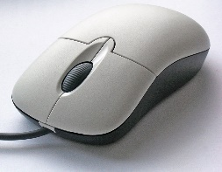
This Photo by Unknown Author is licensed under CC BY-SA

12. 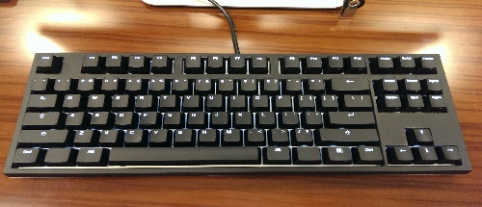
This Photo by Unknown Author is licensed under CC BY
13. 
This Photo by Unknown Author is licensed under CC BY-SA-NC

14. 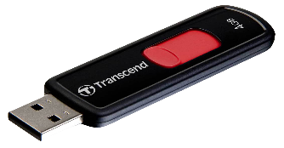
This Photo by Unknown Author is licensed under CC BY-NC

15. 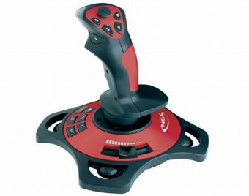
This Photo by Unknown Author is licensed under CC BY-SA-NC

IV. Write YES OR NO for the following statement. (5x1=5)

16. You cannot arrange the icons on the desktop.
17. Mac OS is the most popular operating system.
18. A polygon is a closed figure with more than two number of sides.
19. A dotted circle appears around the selected part.
20. Undo means to cancel the last action.

V. ANSWER IN ONE WORD. (5x1=5)
21. Which program is used to manage files or folders on our computer?
22. Write an example of application software.
23. Which tool is used to magnify the drawing in MS Paint?
24. Which devises is used to record voice?
25. Name the scroll bars?

VI. Write the keyboard shortcut for the following. (6X1=6)
21. Undo –
22. Cut -
23. copy -
24. Redo -
25. Paste –
26. Select all -

- THE FOLLOWING QUESTIONS.
27. What is Screen saver ? (2)
28. How do you change a font? (2)
29. What is a folder? (2)
30. What is the difference between copy and move? (4)
31. How do you erase a character? (2)
32.What are storage devices? Write two examples. (2)

