ALL SAINTS PUBLIC SCHOOL, CHAYAM, VITHURA
SA 1 EXAMINATION (2024-25) CLASS-IV
INFORMATION TECHNOLOGY Marks- 60
NAME :_________________________________________________ ROLL NO._____ DIV.________

I.FILL IN THE BLANKS. (10x2=20)
1. _____________option in the recycle bin should we used to recover the file.
2. ___________command used to reverse the last action.
3. __________ displays the program name and document name.
4. ________________changes all the selected letters in to capital.
5. A computer has ___________ kinds of memory.
6. 0 and 1 are ___________ digits.
7. BD is called ________________.
8. Superscript text is slightly __________ the normal line.
9. ____________ means that data is stored on remote servers using internet.
10. _____________ is a temporary memory.
III. IDENTIFY THE FOLLOWING PICTURES AND WRITE THE NAMES. (5X2=10)

16. 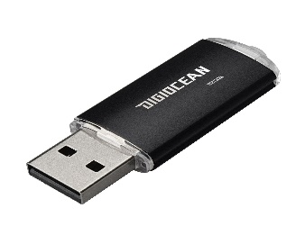- ________________________________
This Photo by Unknown Author is licensed under CC BY-SA-NC

17. 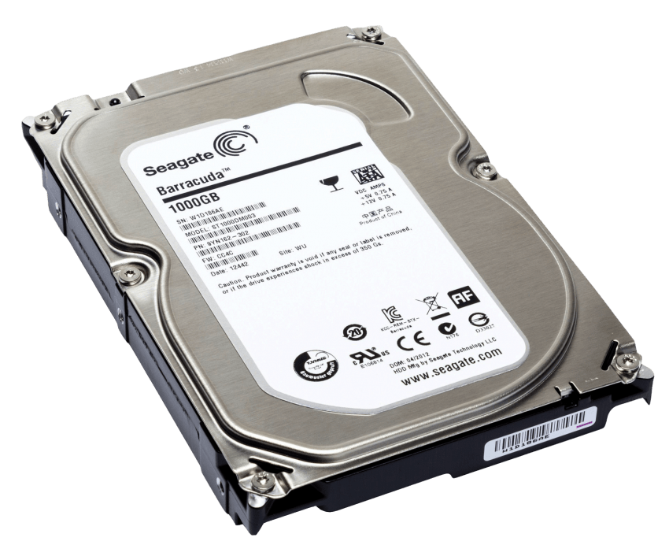- ________________________________
This Photo by Unknown Author is licensed under CC BY-NC

18. 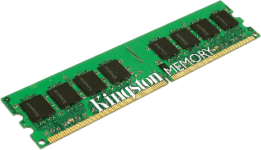

- ________________________________

19. 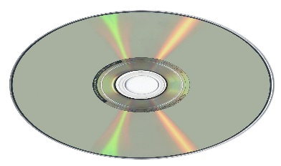- _________________________________
This Photo by Unknown Author is licensed under CC BY-SA
20.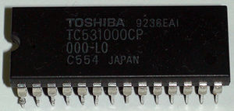-____________________________________

IV. Write YES OR NO for the following statement. (5x1=5)

21.Windows is a CUI based operating system.
22.A folder is a place to store files or other folders.
23. DVD stands for Drawing Video Disk.
24. 8bits make 1 byte.
25. Computer memory is measured in bytes.
V. MATCH THE FOLLOWING. (5x1=5)

26. Sentence case- formatting text in ms word
27. Lowercase - Fomatting Text In MS Word
28. UPPERCASE – f ORMATTING TEXT IN ms wORD
29. Capitalize Each Word –Formatting text in ms word
30. tOGGLE cASE - formatting text in ms word
VI. Write the keyboard shortcut for the following. (6X1=6)
31. Undo –
32. Cut -
33. copy -
34. Redo -
35. Paste –
36. Select all -

- THE FOLLOWING QUESTIONS.
37. What is Screen saver ? (2)
38. How do you change a font? (2)
39. What is a folder? (2)
40. What is the difference between copy and move? (4)
41. How do you erase a character? (2)
42.What are storage devices? Write two examples. (2)

