ALL SAINTS PUBLIC SCHOOL, CHAYAM, VITHURA
SA 1 EXAMINATION (2024-25) CLASS-V
INFORMATION TECHNOLOGY Marks- 60
NAME :_________________________________________________ ROLL NO._____ DIV.________

I.FILL IN THE BLANKS. (10x2=20)
1. ----------------- generates vast amounts of data that can be analysed to gain valuable.
2. The devices that work with the help of the internet are called------------------.
3. A ------------------ represents the data in the form of rows and columns.
4. The ---------------- tab has the option for inserting pictures and wordart.
5. The first women programmer was --------------------.
6. The first counting tool was the----------------.
7. Napier bones were invented by -------------------.
8. ---------------- is an invisible narrow strip that runs along the left edge of a MS Word document window.
9. ----------------- can connect to the internet using Wi-Fi or cell networks.
10. ------------------- discovered tabulation machine.
III. IDENTIFY THE FOLLOWING PICTURES AND WRITE THE NAMES. (5X2=10)

11. 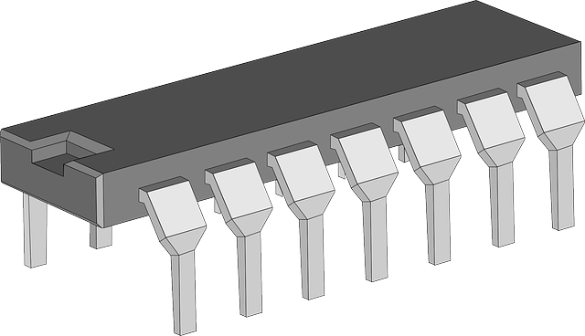

12. 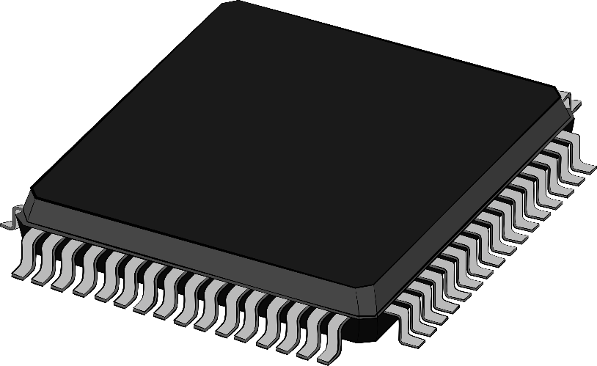
This Photo by Unknown Author is licensed under CC BY-NC
13. 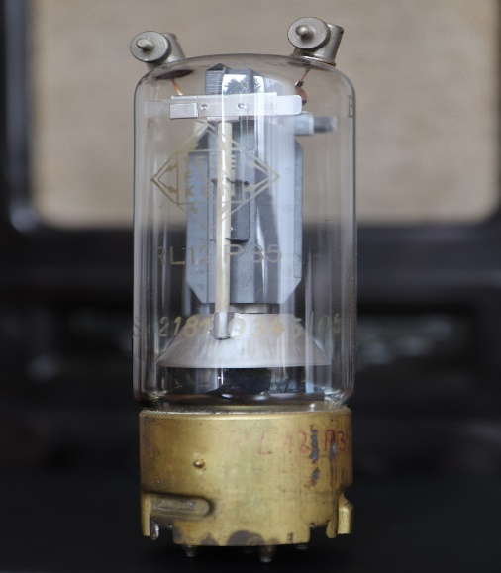

14.
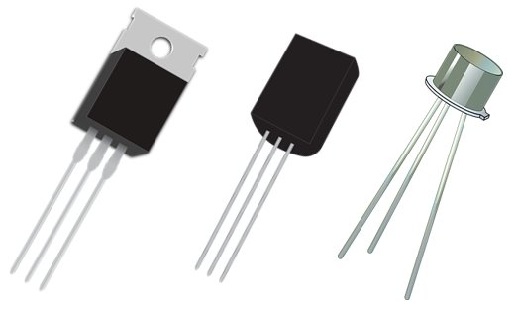

IV. Write YES OR NO for the following statement. (5x1=5)

15. Napier bones was used to do multiplication and division.
16. Smart devices can be controlled and automated through remote-controls.
17. Row height cannot be changed once a table has been created.
18. Splitting means dividing a cell into two or more cells.
19. Picture ,clipart and shapes are available in the illustrations group.
20. UNIVAC is a second generation computer.

V. ANSWER IN ONE WORD. (5x1=5)
21. Select this option to fit the table within the margins.
22. Which feature would you use to capture and insert the image of the character into your document?
23. what was the first electronic computer?
24. Name the process of removal of unwanted part of an image.
25. What is the vertical series of cell known as?

VI. Match the following. (5X1=5)
26. Insert row - Integrated Circuit
27. Split cell - @
28. Symbols - Fifth generation
29. Third generation - Merge group
30.Alexa - Rows and columns group

VII. ANSWER ANY 5 FROM THE FOLLOWING QUESTIONS .

31. How do you divide the cell in to two?
32. How does IoT makes school smarter?
33. What is the difference between four and fifth generation of computers?
34. Write the steps to insert word art in your document?
35. Write any two features of Vaccum tubes?
36.What is word Art?
VIII. WRITE ANY ONE OF THE FOLLOWING. [5 mark)
37. Write the five generation of computers
38.In how many ways you can create a table?

