ALL SAINTS PUBLIC SCHOOL CHAYAM VITHURA
Session: 2024 - 25
MID Term Examination
Class: IX |  | Subject: Mathematics
Time Allowed: 3hrs |  | Max.Marks: 80
General Instructions:
- All the questions are compulsory.
- Section A consists of 20 questions of 1 mark each, section B consists of 5 questions of 2 marks each, Section C consists of 6 questions of 3 marks each, Section-D consists 4 questions of 5 marks each,
Section E consists of 3 case study of 4 mark each.
Section A(1 mark)
1. | If x+2 is a factor of the equation 𝑥² + 𝑚𝑥 + 14 ,then the value of m=  a) 7 b)9 c)14 d) 2 |  | 1
2. | The Point whose abcissa is 4 and which lies on x- axis is a) (4,0) b) (0,4) c) (1,4) d) (4,2) |  | 1
3. | The value of (125) ^{-1/3} is equal to:  a) 5 b) ¹c) ¹ d)- ¹  5 25 5 |  | 1
4. | The value of 1.9999….. in the form p/q, where p and q are integers and q not equal to 0.  a) 3 b) 4 c) 2 d) 1/9 |  | 1
5. | One of the zeros of the polynomial 2𝑥² + 7𝑥 − 4 is  a)2 b)1/2 c) -2 d) -1/2 |  | 1
6. | The degree of the polynomial 3𝑥³ − 𝑥² + 33 is: a)5 b) 3 c) 4 d) 0 |  | 1
7. | In a right angled isosceles triangle ABC, right angled at A, then angle B is equal to :  a)50° b)45° c) 55° d) 25° |  | 1
8. | In ∆ABC and ∆PQR, < 𝐴 =< 𝑃, < 𝐶 =< 𝑅 and  AC = PR. By which congruence rule,∆ABC = ∆PQR?  a) ASA b) RHS c)SASd)SSS |  | 1
9. | The angle which is equal to its complement is: a) 45° b) 90° c) 60° d)180° |  | 1
10. | In ∆ABC, if AB = AC and < B= 40°, then <C=  a) 40° b) 90° c)70° d)60° |  | 1
11. | If 𝑥 + 1 = 5,then 𝑥² + 1 =?  𝑥 𝑥2 |  | 1

 | a) 25 b) 10 c) 23 d) 27
12. | The ordinate of any point on x-axis is  a) 0 b) 1 c) -1 d) Any number | 1
13. | In ∆ABC , if AB = AC, and BC is produced to D such that  < 𝐴𝐶𝐷 = 100°,then < 𝐴𝐶𝐵 =?  a) 20° b) 40° c) 60° d) 80° | 1
14. | If x+2 is a factor of 𝑥² + 𝑚𝑥 + 14, then m=  a) 7 b) 2 c) 9 d) 14 | 1
15. | Which of the following is not a crieterion for congruence of triangles?  a) ASA b) SSA c)SAS d)SSS | 1
16. | ABC is an isosceles triangle such that AB=AC and AD is median to the base BC.Then,< 𝐵𝐴𝐷 =?  a) 55°  b) 70°  c) 35°  d) 110° | 1
17. | The rationalization factor of 3 + √3 is : a) 3 − √3 b) √2 + 3  b) √2 − 3 d) √3 − 2 | 1
18. | The point of intersection of the coordinate axis is:  - Ordinate  - Abscissa  - Quadrant  - Origin | 1
19. | Directions for questions 19 &20: In the following questions, A statement of Assertion (A) is followed by a statement  of Reason (R),  a) both Assertion and reason are correct and reason is correct explanation for Assertion. | 1
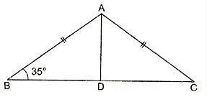

- both Assertion and reason are correct but reason is not correct explanation for Assertion.
- Assertion is correct but reason is false.
- both Assertions and reason are false.

Assertion : 3x² + x – 1 = (x + 1) (3x – 2) + 1.
Reason : To factorise ax² + bx + c, write b as sum of two numbers whose product is ac.
20. | Assertion : The degree of the polynomial (x – 2 )(x – 3 )(x + 4) is 4.  Reason : The number of zeroes of a polynomial is the degree of  that polynomial. | 1
 | Section B (2 marks)
21. | Find two rational numbers between ³ 𝑎𝑛𝑑 4.  5 3 | 2
22. | Simplify: (36)−2 −× (27)⁻2  3 3  OR  1  If z =0.0049, find the value of ⎛ ¹ ⎞2  ⎜ z ⎟  ⎝ ⎠ | 2
23. | If f(x) = 𝑥³ − 13𝑥² + 17𝑥 + 12, find f(2) and f(-3). | 2
24. | Find the product using suitable identity: (5x + 3y) (5x – 3y)  OR  Find the value of (999)³by using suitable identity . | 2
25. | In figure , POQ is a line. Find the value of x.  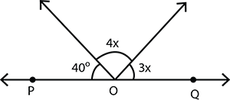 | 2
 | Section C(3 marks)
26. | In ∆ABC, AD is the perpendicular bisector of BC. Show that  ∆ABC is an isosceles triangle in which AB = AC. | 2

 | 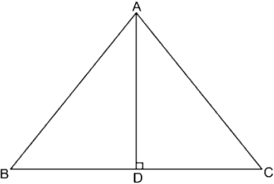
27. | Simplify : ¹⁶  4−√32  OR  If 5+√11 = 𝑎 + 𝑏√11, then find the values of a and b.  3−2√11 | 3
28. | Use the factor theorem to determine whether q(x) is a factor of p(x)  where 𝑝(𝑥) = 𝑥³ + 3𝑥² + 3𝑥 + 1 and q(x)= x+2. | 3
29. | Factorise: 3𝑥² − 𝑥 − 4  OR  Factorise: y³+13y²+32y+20 | 3
30. | Find the values of a and b so that the polynomial  𝑝(𝑥) = 𝑥³ − 𝑎𝑥² − 13𝑥 + 𝑏 is exactly divisible by (x-1)and (x+3). | 3
31. | On a graph paper draw the quadrilateral ABCD whose vertices are  A (3,2), B(2,-3), C ( -4,-5) and D (-5,3). | 3
32. | Plot the following points (1,2),(0,3),(-1,2), (3,0) | 3
 | Section D(5 marks)
33. | In figure, if AB || CD, EF || CD and <GED = 136°, find <AGE,  <GEF and <FGE. | 5

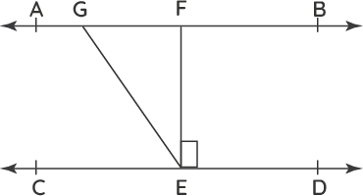

OR
In figure, if AB || CD, <APQ = 50° and <PRD = 127°, find x and y.

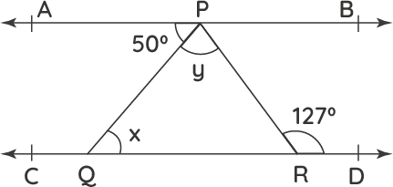

34. | ABC is an isosceles triangle in which altitudes BE and CF are drawn to equal sides AC and AB respectively(see figure).Show that altitudes are equal.  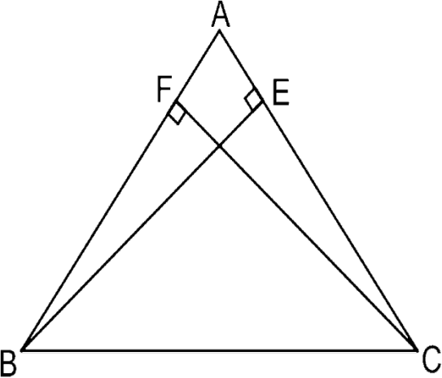 | 5

35. | In right triangle ABC, right angled at C, M is the midpoint of hypotenuse AB. C is joined to M and produced to a point D such that DM= CM. Point D is joined to point B. Show that:  - ∆AMC = ∆BMD  - <DBC is a right angle.  - ∆DBC= ∆ACB  - CM =1/2 AB  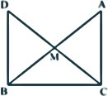 | 5
36. | Factorise:  (i) 27𝑥³ + 343𝑦³  (ii) 2𝑥² + 𝑦² + 8𝑧² − 2√2𝑥𝑦 + 4√2𝑦𝑧 − 8𝑥𝑧  OR  If x+y+z=0 then show𝑥³ + 𝑦³ + 𝑧³ = 3𝑥𝑦𝑧. | 5
37. | The cost of petrol in a city is D80 per litre.Set up an equation with  x representing the total cost(in rupees).Draw the graph also. | 5
 | Section E (4 marks)
38. | Case study:  Prime Minister's National Relief Fund (also called PMNRF in short) is the fund raised to provide support for people affected by natural and man-made disasters. Natural disasters that are covered under this include flood, cyclone, earthquake etc. Man- made disasters that are included are major accidents, acid attacks, riots, etc.   | 4

Two friends Sita and Gita, together contributed D 200 towards Prime Minister's Relief Fund. Based on the above information answer the following questions :
- How to represent the above situation in linear equations in two variables ?
- If Sita contributed D 76, then how much was contributed by Gita ?
- If both contributed equally, then how much is contributed
by each?
39. | Case study:  Students of a school are standing in rows and columns in their playground for a drill practice. A, B, C and D are the positions of four students as shown in the figure. Based on the above information answer the following questions :  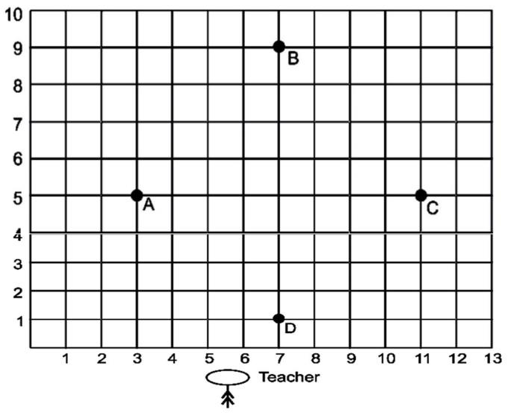  - What are the coordinates of A and B respectively?  - What are the coordinates of C and D respectively?  - What is the distance between B and D?  - What are the coordinates of the point of intersection of AC and BD? | 4
40. | Case study:  Learning by Doing has a great impact in teaching of Maths. Students also enjoy mathematics by activity method. Suman, a student of class IX explaining the concept by a very thin steel wire. She used steel wire and made some shapes at some specific angles and shown to the friends and asked questions:  (a) What is the measure of ∠1 where AB||EF||DC? | 4

- What is the measure of ∠2?
- What is the measure of reflex ∠2?



