ALL SAINTS PUBLIC SCHOOL, CHAYAM
STD: X SCIENCE
Multiple Choice Questions carries 1 mark.
1. If a beam of red light and a beam of violet light are incident at the same angle on the inclined surface of a prism from air medium and produce angles of refraction r and v respectively, which of the following is correct?
A. r = v B. r > v C. r = 1/v D. r < v
2. Consider these indices of refraction: glass: 1.52; air: 1.0003; water: 1.333. Based on the
refractive indices of three materials, arrange the speed of light through them in
decreasing order.
A. The speed of light in water > the speed of light in air > the speed of light in glass.
B. The speed of light in glass > the speed of light in water > the speed of light in air.
C. The speed of light in air > the speed of light in water > the speed of light in glass.
D. The speed of light in glass > the speed of light in air > the speed of light in water.
3. Which diagram shows image formation of an object on a screen by a converging lens?
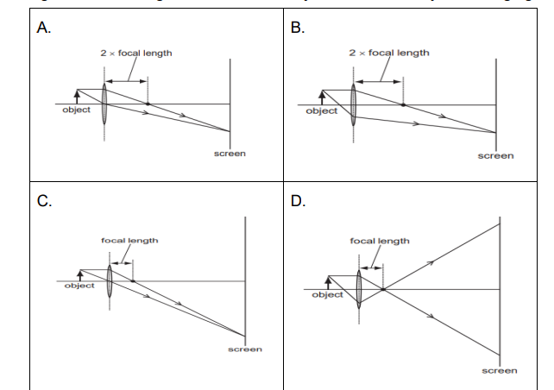
4. Which of the following can make a parallel beam of light when light from a point source is
incident on it?
A. Concave mirror as well as convex lens.
B. Convex mirror as well as concave lens.
C. Two plane mirrors placed at 90° to each others.
D. Concave mirror as well as concave lens
Assertion and Reason
- Assertion: Sky appears blue in the day time.
Reason: White light is composed of seven colours
- Assertion: A fuse wire is always connected in parallel with the mainline.
Reason: If a current larger than the specified value flows through the circuit, fuse wire
Melts.
SECTION B (2 Marks each)

- 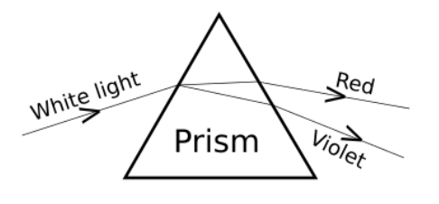
A student observes the above phenomenon in the lab as a white light passes through a prism. Among many other colours, he observed the position of the two colours Red and Violet. What is the phenomenon called? What is the reason for the violet light to bend more than the red light?

2.

How will you use two identical prisms so that a narrow beam of white light incident on one prism emerges out of the second prism as white light? Draw the diagram.

SECTION C (3 Marks each)
1. Rohit wants to have an erect image of an object using a converging mirror of focal
length 40 cm.
(a) Specify the range of distance where the object can be placed in front of the
mirror. Justify.
(b) Draw a ray diagram to show image formation in this case.
(c) State one use of the mirror based on the above kind of image formation.
2. It is desired to obtain an erect image of an object, using concave mirror of focal length of 12 cm. (i) What should be the range of the object distance in the above case? (ii) Will the image be smaller or larger than the object? Draw a ray diagram to show the formation of image in this case. (iii) Where will the image of this object be, if it is placed 24 cm in front of the mirror?
3. Define ohm’s law? Write the activity to verify it.

SECTION D 4 marks
- Read the questions given below and answer any four.
Sumati wanted to see the stars of the night sky. She knows that she needs a
telescope to see those distant stars. She finds out that the telescopes, which are made of lenses, are called refracting telescopes and the ones which are made of mirrors are called reflecting telescopes. 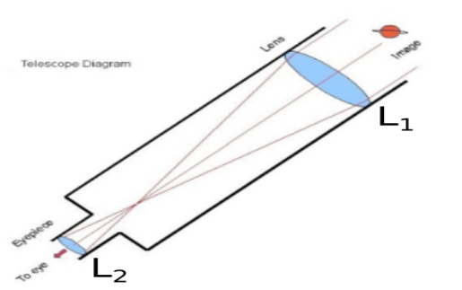

So she decided to make a refracting telescope. She bought two lenses, L1 and
L2. out of which L1 was bigger and L2 was smaller. The larger lens gathers and
bends the light, while the smaller lens magnifies the image. Big, thick lenses
are more powerful. So to see far away, she needed a big powerful lens.
Unfortunately, she realized that a big lens is very heavy.
Heavy lenses are hard to make and difficult to hold in the right place. Also
since the light is passing through the lens, the surface of the lens has to be
extremely smooth. Any flaws in the lens will change the image. It would be
like looking through a dirty window.
(i) Based on the diagram shown, what kind of lenses would Sumati need to make the telescope?
a) Concave lenses b) Convex lenses c) Bifocal lenses d) Flat lenses
(ii) If the powers of the lenses L1 and L2 are in the ratio of 4:1, what would be the ratio of the focal length of L1 and L2?
a) 4:1 b) 1:4 c) 2:1 d) 1:1
(iii) What is the formula for magnification obtained with a lens?
a) Ratio of height of image to height of object
b) Double the focal length.
c) Inverse of the radius of curvature.
d) Inverse of the object distance.
(iv) Sumati did some preliminary experiment with the lenses and found out that the magnification of the eyepiece (L2) is 3. If in her experiment with L2 she found an image at 24 cm from the lens, at what distance did she put the object?
a) 72 cm b) 12 cm c) 8 cm d) 6 cm
(v) Sumati bought not-so-thick lenses for the telescope and polished them. What advantages, if any, would she have with her choice of lenses?
a) She will not have any advantage as even thicker lenses would give
clearer images.
b) Thicker lenses would have made the telescope easier to handle.
c) Not-so-thick lenses would not make the telescope very heavy and also
allow considerable amount of light to pass.
d) Not-so-thick lenses will give her more magnification.
Section E
- (i) A lens produces a magnification of -0.5. Is this a converging or diverging lens? If the focal length of the lens is 6 cm, draw a ray diagram showing the image formation in this case.
(ii) A girl was playing with a thin beam of light from a laser torch by directing it from different directions on a convex lens held vertically. She was surprised to see that in a particular direction, the beam of light continues to move along the same direction after passing through the lens. State the reason for her observation. Draw a ray diagram to support your answer.
OR
(i) On entering in a medium from air, the speed of light becomes half of its value in air. Find the refractive index of that medium with respect to air?
(ii) A glass slab made of a material of refractive index n1 is kept in a medium of refractive index n2.
A light ray is incident on the slab. Draw the path of the rays of light emerging from the glass slab, if (i) n1> n2 (ii) n1 = n2 (iii) n1< n2

