ALL SAINTS PUBLIC SCHOOL, CHAYAM VITHURA (2024-25)
MID TERM EXAMINATION ( SEPTEMBER)
SUBJECT- MATHEMATICS (041) TIME: 3 hrs
CLASS:- X M.M: 80
General Instructions
I. All questions are compulsory.
II. The question paper consists of 38 questions divided into five sections A, B, C, D and E.
II. Section A has 20 questions of 1 mark each (18 MCQ’s and 2 Assertion and Reason based questions), Section B has 5 questions of 2 marks each, Section C has 6 questions of 3 marks each, Section D has 4 questions of 5 marks each and Section E has 3 source based questions of 4 marks each.
Q. NO. | SECTION - A | Marks
1 | LCM of two numbers is 2295 and HCF is 9. If one of the numbers is 153, the other number is  a) 1035 b) 45 c) 145 d) 135 | 1
2 | A quadratic polynomial whose zeroes are -5 and 6 is  a) x² + x – 30 b) x²$-$ x – 30  c) x² + 5x + 6 d) x² $-5$x + 6 | 1
3 | If the system of linear equations 2x + 3y =7 and kx + 9y = 15 has a unique solution, then the value of k is  a) k= 6 b) k = -6 c) k $≠$ $-$ 6 d) k $≠$ 6 | 1
4 | If 8 is a root of the equation x² $-$ 10x + k = 0, then the value of k is  a) 2 b) 8 c) – 8 d) 16 | 1
5 | If p $-$1, p + 3 and 3p – 1 are in A.P, then p is equal to  a) 4 b) – 4 c) 2 d) – 2 | 1
6 | If R(–1,1) is the mid-point of the line segment joining P(-3, p) and Q(1, p+4) the value of p is  a) – 1 b) 0 c) 1 d) 2 | 1
7 | The mode and mean is given by 7 and 8, respectively. Then the median is:  (a) 1/13 (b) 13/3 (c) 23/3 (d) 33 | 1
8 | If two positive integers A and B can be expressed as A= xy³ and B = x⁴y²z  x,y being prime numbers, the LCM (A, B) is  (a) xy² (b) x⁴y²z (c) x⁴y³ (d) x⁴y³z | 1
9 | The sum of the digits of a two-digit number is 9. If 27 is added to it, the digits of the number get reversed. The number is  (a) 27 (b) 72 (c) 45 (d) 36 | 1
10 | Which of the graph is not the graph of quadratic polynomial ?  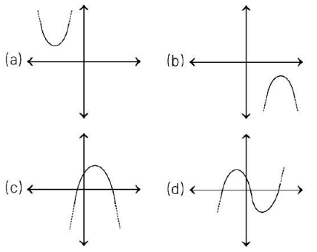 | 1
11 | The 7th term from the end of the A.P. 7, 11, 15, …,107 is  a) 79 b) 83 c)81 d) 87 | 1
12 | The roots of the equation (b – c) x² + (c – a) x + (a – b) = 0 are equal, then  (a) 2a = b + c (b) 2c = a + b (c) b = a + c (d) 2b = a + c | 1
13 | The distance of the point (– 3,4) from the x-axis is  a) 3 b) –3 c) 4 d) 5 | 1
14 | If S_{n} = n² + 13 of an A.P., then its 13th term is  a) 25 b) 24 c) 13 d) 20 | 1
15 | If $α$ and $β$ are the roots of the quadratic equation x² – 5x + 6 = 0, then  $α^{2}$ – $β^{2}$ is equal to  a) ± 5 b) ± 6 c) ± 7 d) ± 13 | 1
16 | If the distance between the points (x, -1) and (3, 2) is 5, then the value  of x is  (a) -7 or -1 (b) -7 or 1 (c) 7 or 1 (d) 7 or -1 | 1
17 | The line 3x + 4y = 12 meets x-axis at  a) (3,0) b) (0,3) c) (4,0) d) (0,4) | 1
18 | Which term of an A.P. 100, 90, 80, …. is zero?  a) 5th b) 6th c) 10th d) 11th | 1
The following questions consists of two statements- Assertion (A) and Reasoning (R ). Answer these questions selecting the appropriate option given below:
a) Both A and R are true and R is the correct explanation of A.
b) Both A and R are true and R is not the correct explanation of A.
c) A is false but R is true.
d) A is true but R is false.
19 | Assertion (A): $\sqrt{2}$ is an irrational number.  Reasoning (R) : The square root of a prime number is rational number. | 1
20 | Assertion (A): If x=1 and y=4 is the solution of the linear equation  3x + ky = 27, then value of k is 6.  Reasoning (R) : The solution of linear equation in two variable will satisfy the equation. | 1
 | SECTION B
21 | Prove that $\sqrt{3}$ is an irrational number. | 2
22 | If the sum of the squares of zeros of the quadratic polynomial f(x) = x² – 8x + k is 40, then find the value of k. | 2
23 | Find the roots of 4$\sqrt{3}$ x² + 5x - 2$\sqrt{3}$ by factorization method. | 2
24 | Find the 15th term from the end in the A.P. 9, 14, 19, 24, …., 154. | 2
25 | Which term of the progression 20, 192, 183, 17 … is the first negative term? | 2
 | SECTION C
26 | Check whether 15^{n} can end with the digit zero for any natural number n. | 3
27 | If $α$ and $β$ are zeroes of the quadratic polynomial 2y² + 7y + 5, then find the value of $αβ$ + $α$ + $β$. | 3
28 | Heights of students of class X are given in the following frequency distribution:  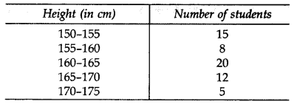  Find the modal height. | 3
29 | If the point C (–1,2) divides the line segment joining A(2,5) and B(x,y) in the ratio 3:4, then find the coordinates of B. | 3
30 | The 9th term of an A.P. is equal to 6 times its second term. If its 5th term is 22, find the A.P.  OR  The first term of an A.P. is 5, the last term is 45 and the sum of all its terms is 400. Find the number of terms and the common difference of the A.P. | 3
31 | Find the value of k such that the quadratic equation  (k – 12)x² + 2(k - 12)x + 2 = 0 has equal roots. | 3
 | SECTION – D
32 | The total expenditure per month of a household consists of a fixed rent of house and mess charges depending upon the number of people sharing the house. The total monthly expenditure is Rs 3900 for two people and Rs 7500 for five people. Find the rent (in Rs) of the house. | 5
33 | A fast train takes 3 hours less than a slow train for a journey of 600 km. If the speed of the slow train is 10 km/hr less than the fast train, then find the speed of both the trains.  OR  A motorboat whose speed in still water is 18 km/h, takes 1 hour more to go 24 km upstream than to return downstream to the same spot. Find the speed of the stream | 5
34 | Find the values of x and y if the median for the following data is 31.  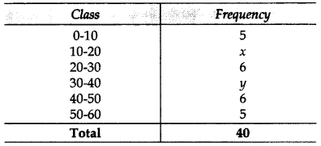 | 5
35 | The line segment joining the points A(3,2) and B(5,1) is divided at a point P in the ratio 1:2 and it lies on the line  3x – 18y + k = 0. Find the value of k. | 5
 | SECTION - E (CASE BASED QUESTIONS)
36 |   Bus fare for purchasing two tickets to station A and three tickets to station B from Jalandhar is Rs 385. If we buy three tickets to station A and five tickets to station B from Jalandhar the fare is Rs 620. Consider the bus fares from Jalandhar to station A and that to station B are respectively Rs x and Rs y.  (i) Represent the first situation algebraically.  (ii) Represent the second situation algebraically.  (iii) Calculate the bus fare from Jalandhar to station A. | 1  1  2
37 |   India is competitive manufacturing location due to the low cost manpower and strong technical and engineering capabilities contributing to higher quality production runs. The production of TV sets in a factory increases uniformly by a fixed number every year. It produced 16,000 sets in 6th year and 22,600 in 9th year. Based on this information, answer the following:  (i) Find the number of TV sets produced during the 8th year ?  (iv) In which year production was 29,200 TV sets ? | 2  2
38 |   A rainbow is an arc of colours that is visible in the sky caused by the refraction and dispersion of the sun’s light after rain or other water droplets in the atmosphere. Each colour of the rainbow makes a parabola.  (i) If x² – 2x – (7p+3) represents a rainbow and – 4 is the zero of the polynomial, the find value of p is  (ii) If the parabola of rainbow is x² + 2x – 15 the Find its zeroes ? | 2  2

****************************************************

