ALL SAINTS PUBLIC SCHOOL
MID TERM EXAMINATION 2024-25
HISTORY
Class : 11
Marks : 80
GENERAL INSTRUCTIONS
- Question Paper comprises five Sections A, B, C, D and E
- Question number 1 to 21 are objective type questions carrying 1 mark each.
- Answer to question number 22 to 30( answer any 6) carrying 3 marks should not exceed 80 words each.
- Answer to question number 31to 33 carrying 8 marks should not exceed 350 words each.
- Answer to question number 34 to 37 are source based questions carrying 3 marks each.
- Question number 38 is map question of 5 marks.

SECTION A 21 Marks
( Objective Type Questions )

- What is the meaning of Mesopotamia?
( Land between two bridges, Land between two rivers, Land between two poles, None Of these)
- Which was the first known language of Mesopotamia?
( German, Japanese, Urdu, Sumerian )
- Which of these was the oldest Mesopotamian town?
( Ur, Urr, Sumeria, Raur )
- The Roman Empire extended over how many continents?
( One, Two, Three, Four )
- Consider the following statements and identify the correct reasons.
  - Symbols were no longer understood by people.
  - When society needed to keep records of transactions.
  - When foreigners visited different nations.
  - All of the above.
- Find out the following pairs which one is correctly matched.(2)
- a) Feud : Latin word
b)Gaul : Province of the Roman Empire.
c)Priests : Third Order.
d) Pope: Head of The Eastern Church.

- a)Monks : lived in Church
b)Christ's birth : 31 st December
c) Taille : Direct Tax
c) Guild : Basis of social organization.
8)Who were Nomads?
( Farmers, Pastorals, Wanderer tribes, Kings )
9)Who were Mongols?
( Fierce nomadic tribes of Central Asian Steppes, A ruling class, Labours, Settled tribes)
10) Who were the greatest Mongol ruler?
( Aurangzeb, Mohammed Ghazni, Alau-din-Khilji, Genghis Khan )
Fill in the blanks
11)….. dynasty ruled over South China.
12)The Three orders comprised of…., nobility and peasantry.
13) The…. Could not leave the estate without the permission of their masters / lords.

14) Which of these is not a source for the European history for the medieval period?
( Documents, Details of land ownerships, prices and legal cases, Records kept at churches regarding births, marriages and deaths, Narratives of Feudal lords)
15) What is the name given to the economic, political and social relations that existed in Medieval Europe?
( Socialism, Communism, Feudalism, Capitalism)
Assertion – Reason Questions
For each part choose from the following
- Both A and R are true and R is the correct explanation of A
- Both A and R are true but R is not the correct explanation of A
- A is true but R is false.
- A is false but R is true
16)Assertion ( A) :The invasions that were led by Genghis Khan were successful.
Reason ( R) : Genghis Khan had reorganized the Mongol people into a more effective, disciplined military force.
17) Assertion (A ) : The senate hated and feared the army.
Reason ( A ) : The empire inherited by Tiberius from Augustus was already so vast that further expansion was felt to be unnecessary.
18) Assertion ( A ) : There was a close interaction between Greek and Islamic traditions in the region.
Reason ( R ) : The Mongol Empire of Genghis Khan and his successors is a good example of how an empire could be maintained by military assets.
True or False
19) Gilgamesh was the greatest epic of Mesopotamians.
20)Very few people in Mesopotamia could read or write.
21) Identify the following image and write the names.

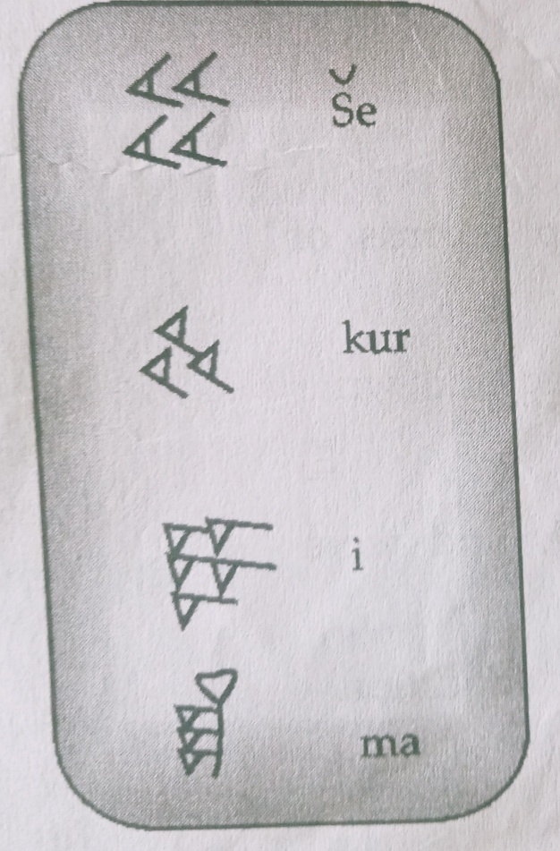

SECTION : B ( 18 Marks )
Short Answer Type Question ( answer any six)
22)What story of the flood mentioned in the Bible, had a similarity in Mesopotamian tradition?
23) Describe the geographical location of Mesopotamia.
24) What is the importance of clay tablets as evidence for Mesopotamian history?
25) Briefly discuss the sources which helped to reconstruct Roman history.
26) How did the emperors control and administer the vast Roman empire?
27) Write a note on the economic reforms undertaken by Augustus.
28) Throw some light on the early life of Genghis Khan.
29) What are the sources for the study of the Mongol empire?
30) Define the term Feudalism.

SECTION : C ( 24 Marks )
LONG ANSWER QUESTIONS
31) Describe the features of Feudalism
OR
Discuss the factor responsible for the decline of Feudalism.
32) Describe the steps taken by Genghis Khan to reorganise the people into more effective and disciplined military force.
OR
Why was it felt necessary to mould the Mongol tribe into a new social and military organization.
33) “ Roman Civilization flourished in the Mediterranean region. It had contributed a lot to the world civilisation “. With the help of examples, describe the contribution of this civilisation.
OR
What is the legacy of Mesopotamia to the world?

SECTION : D ( 12 Marks )
SOURCE BASED QUESTION
Read the following extract carefully and answer the following questions
To sun the emperor, the aristocracy and the army were the three main players in the political history of the empire. The success of individual Emperos depended on their control of the army, and when the armies were divided, the result usually was civil war. Except for one notorious year 69 CE, when four emperors mounted the throne in quick succession, the first two centuries were on the whole free from civil war and in this sense relatively stable. Succession to the throne was based as far as possible on the family descent, either natural or adaptive, and even the army was strongly wedded to the principal. For example, Tiberius 14-37CE, the second in the long line of Roman Emperors, was not the natural son of Augustus, the ruler who found the Principate, but Augustus adopted him ensure a smooth transition.
34) Who were the three main players in the early empire?
35) On which the factor did the success of emperor depend upon?
36) Who established regime ”The Principate”?
37) What do you think the term “Republic “ refers to in the history of Roman Empire?

SECTION : E ( Marks 5)
Map Based question
38) On the given political map of world, locate the following places.
1) Venice
2) Mediterranean Sea
3) Gaul
4) Germany
5) Mongolia.

