ALL SAINTS PUBLIC SCHOOL, CHAYAM.
STD: XII PHYSICS (042) MARKS:70
SECTION A
1. An electric dipole placed in a non uniform electric field will experience . (2021)
a) only a force b) only a torque c) both force and torque d) neither force nor torque
2. The electric flux through a closed Gaussian surface depends upon . (2020)
a) Net charge enclosed and permittivity of the medium.
b) Net charge enclosed, permittivity of the medium and the size of the Gaussian surface.
c) Net charge enclosed only. d) Permittivity of the medium only.
3) E and B vectors represent electric and magnetic fields of an electromagnetic fields of an electromagnetic wave respectively. ? The direction of propagation of the wave is along
a) E.B b) B.E c) EXB BXE 2023
4. A capacitor and an inductor are connected in two different ac circuits with a bulb glowing in each circuit. The bulb glows more brightly when: 2021
a) the number of turns in the inductor is increased.
b) The separation between the plates of the capacitor is increased.
c)An iron rod is introduced into the inductor.
d) A dielectric is introduced into the gap between the plates of the capacitor.
5. The phase difference between the current and the voltage in series LCR circuit at resonance is
a) π b) ) π/2 c) ) π/3 d) zero 2020
6. A circular current carrying coil produces a magnetic field B₀ at its center. The coil is rewound so as to have three turns and the same current is passed through it. The new magnetic field at the center is :
a) 3B₀ b) B₀/3 c) B₀/9 d) 9B₀
7. Which one of the following is not affected by the presence of a magnetic field?
a) A current carrying conductor. b) A moving charge c) A stationary charge. d) A rectangular current loop with its plane parallel to the field.
8. A current of 0.8 A flows in a conductor of 40 Ω for 1 minute. The heat produced in the conductor will be
a) 1445 J b) 1536 J c) 1569 J d) 1640 J
9. The selectivity of a series LCR a.c. circuit is large, when
- L is large and R is large
- L is small and R is small
- L is large and R is small
- L=R 2020
10. An electro is projected with velocity v along the axis of a current carrying long solenoid. Which one of the following is true?
- The path of the electron will be circular about the axis
- The electron will be accelerated along the axis
- The path of the electron will be helical
- The electron will continue to move with the same velocity v along the axis of the solenoid. 2021
11. Which among the following is not attracted by the magnets?
- Cobalt
- Copper
- Iron
- Nickel
12. Kirchoff’s current law at a junction deals with
- Conservation of energy
- Conservation of momentum
- Conservation of angular momentum ﻿
- Conservation of charge
13. The capacitance of a parallel plate capacitor depends upon
- The type of metal used
- Separation between the plates
- Thickness of the plate
- Potential difference between the plates
14. The emf induced in a 10 H inductor in which current changes from 1 A to 2 A in m 1.9 x 10⁻¹ s is : 2021
- 10⁴ V
- 10³ V
- 10² V
- 10 V

Assertion and Reasoning
a) Both A and R are true and R is the correct explanation of A.
b) both A and R are true but R is not the correct explanation of A.
c) A is true but R is false.
d) A is false and R is also false.
15. Assertion: Diamagnetic substances exhibit magnetism.
Reason: Diamagnetic materials do not have permanent magnetic dipole moment.
16.Assertion: In a series LCR circuit connected to an ac source, resonance can take place.
Reason: At resonance X_{L} =X_{C} 2021

SECTION B (2marks each)
17. A uniform wire of length L and area of cross section A has resistance R. The wire is uniformly stretched so that its length increases by 25%. Calculate the percentage increases in the of the wire. 2023
18. Define an equipotential surface. Draw equipotential surface. 2020
i) in the case of a single point charge and
ii) in a constant electric field in z direction.
19. Nochrome and copper wires of same length and area of cross section are connected in series, current is passed through them. Why does the nichrome wire get heated first? 2017
20. Write two characteristics of electromagnetic waves. 2021C
21. Using Kirchoff’s rule, calculate the current through the 40 Ω and 20 Ω resistors in the following circuit. 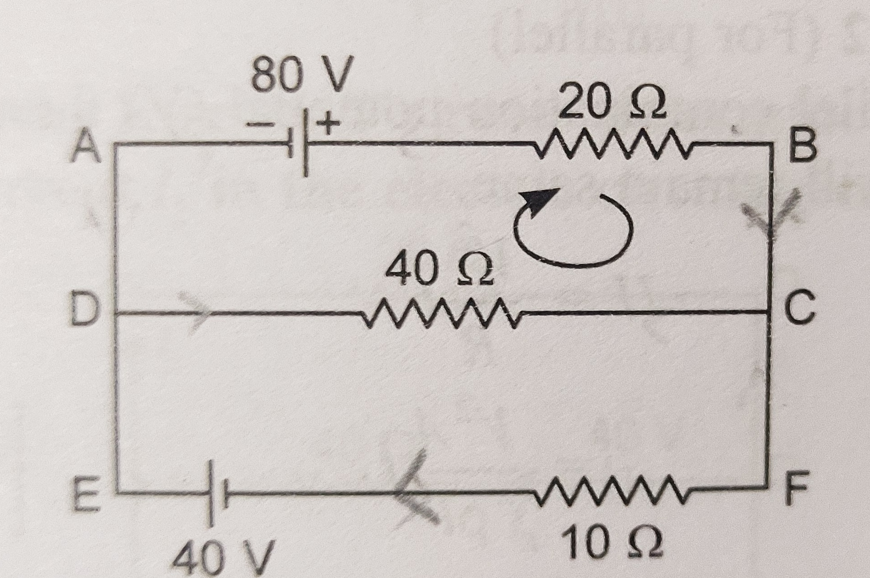

SECTION C (3 Marks each)
22.Write the principle of working of an ac generator. Derive the expression for the induced emf generated in it.
- Write the function of slip rings in an ac generator. 2020 C
23. Which of the following electromagnetic waves has a) minimum wavelength and b) minimum frequency? Write one use of each of these two waves.
Infrared waves, Microwaves, Gamma rays and X-rays 2020
24. The primary coil of an ideal step-up transformer has 100 turns and transformation ratio is also 100. The input voltage and power are respectively 220 V and 1100W . Calculate
i) number of turns in secondary ii) current in primary
iii) voltage across secondary iv) current in secondary v) power in secondary. D19
25. Define relaxation time of free electrons drifting in a conductor. How is this related to the drift velocity of free electron? Use this relation to deduce the expression for the electrical resistivity of the material.
26. Write three points of difference between para-,dia- and ferro- magnetic materials, giving one example for each. 2019
27. Draw the diagram of the device which is used to decrease high a.c. voltage into low a.c. voltage and state its working principle. Write four sources of energy loss in this device. 2019
28. a) Write the expression of the force F acting on a particle of a mass m and charge q moving with velocity v in a magnetic field B. Under what conditions will it move in (i) Circular path and (ii) Helical path?
b) Show that the Kinetic energy of the particle moving in magnetic field remains constant. 2019 D

SECTION D
CASE BASED QUESTIONS
29. An induced emf can be generated by various methods. An emf can be set up in a coil by changing the magnetic field. By moving a magnet closer to stationary coil or by moving the coil towards a stationary magnet, an emf can be induced. Emf is also induced by varying current in the coil or by changing its area. The emf when produced due to motion of a conductor is termed as motional emf. This emf is directly proportional to the magnetic field applied, velocity of the conductor and length of the arm of conductor which is in motion.
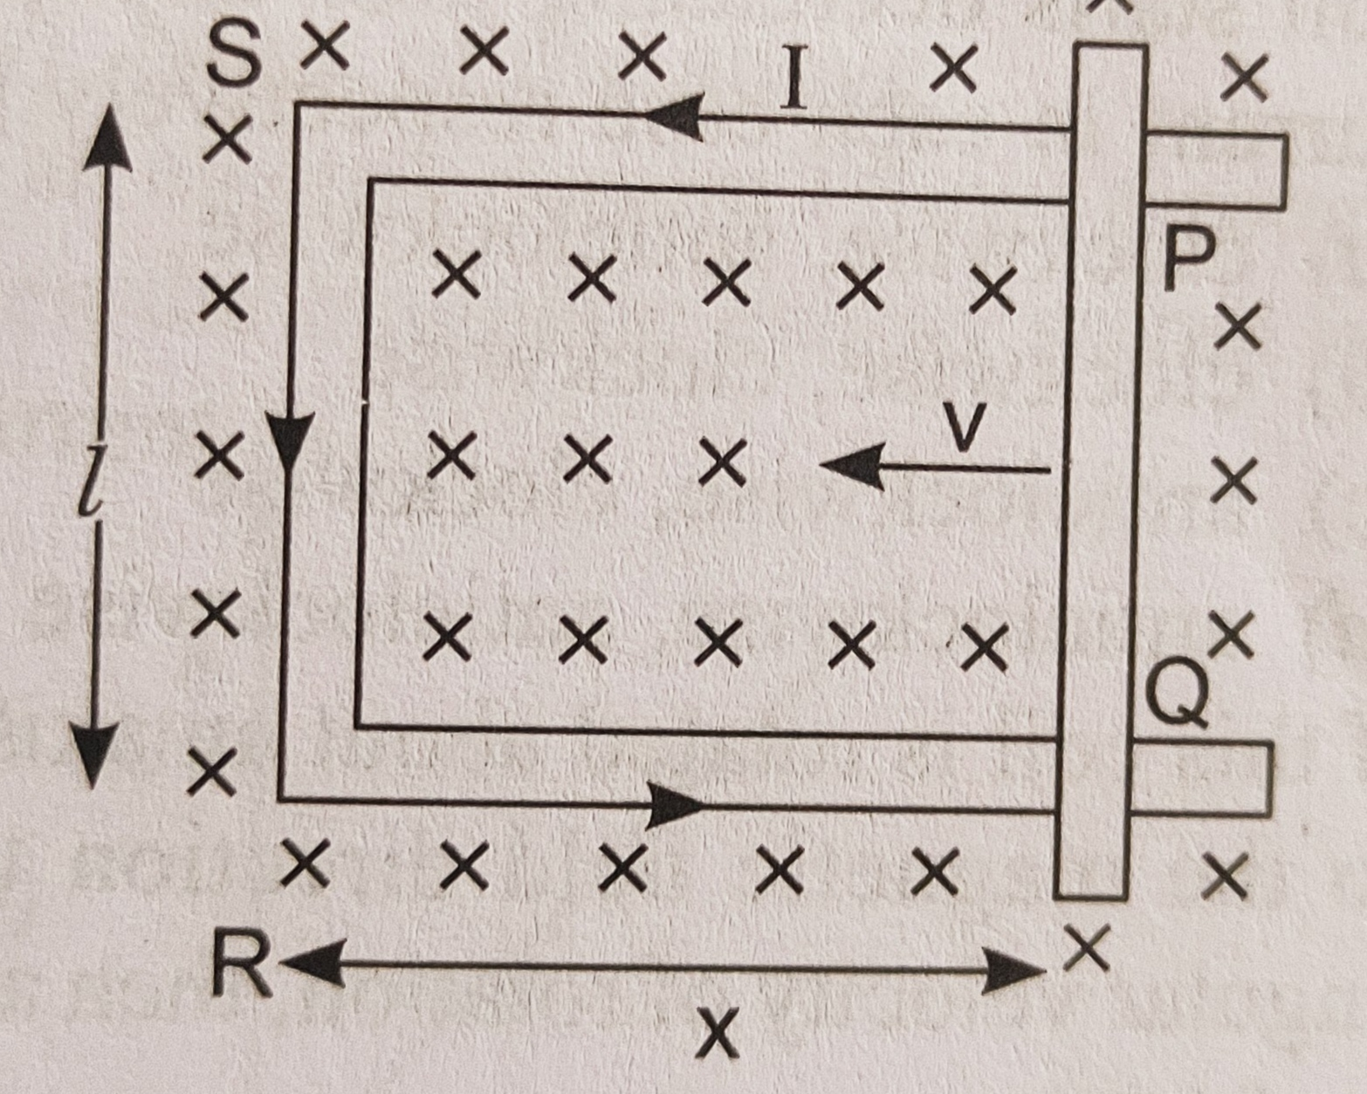
- What is motional emf?
- The emf produced due to change in area of the conductor in magnetic field.
- The emf induced due to rotations of a conductor in the magnetic field.
- The emf induced due to motion of the conductor in the magnetic field.
- The emf induced due to change in magnetic gield linked with the conductor.
- Which of the following is relation for motional emf?
- B²vl b) B²vl² c)Bvl c) B²vl
- On which factor does the motional emf depend?
- Magnetic field applied
- Velocity of the conductor
- Length of the arm of conductor which is in motion.
- All of these.
- What is the other way of inducing emf ina coil?
- By changing magnetic field intensity.
- By changing the angle between magnetic field and area vector.
- Both a) and b. d) None of these.
or
- If length of the conductor PQ is 100 cm, moves at right angle to a uniform field of flux density 1.5 wb/m2 with a velocity of 50m/s. The emf induced in the conductor will be
- 150 V b) 75 V c) 50 V d) 37.5 V
30. In a small field, ferromagnetic materials typically have much larger susceptibility, and therefore larger permeability than paramagnetic material. Ferromagnetism results because of spontaneous , self-aliging, coperative interactions among relatively large number of iron atoms in regions called domains. As a result of molecular interations, the molecular magnetic moments in each domain are allinged parallel to one another. In other words each domain is spontaneously magnetized to saturation even in the absence of any external magnetic field. The direction of magnetistion in different domais are random, so that the resultnat magnetization is zero and the specimen is unmagnetized.
- What cahnges will occur in specimen on placing it inside a solenoid and increasing H (magnetising intensity)?
- Intesity of magnetisation decreases
- Intensity of magnetisation increases
- Magnetic susceptibility of speciemen increases
- Magnetic susceptibility of speciemen decreases
- With an increases in temperature, magnetic suscptibility of a ferromagnetic material _________.
- Decreases
- Increases
- Remains constant
- First increases then decreases
- For a diamagentic material, which of the following option is correct?
- Magnetic susceptibility < 0
- Magnetic susceptibility > 0
- Magnetiv susceptibility = 0
- Magnetic susceptibility = 1
- The property possesed by a ferromagnetic substance only is
- Hysteresis
- Susceptibility
- Directional property
- Attracting a magnetic substance
OR
iv. Which one of the following is not a ferromagnetic material
- Cobalt
- Iron
- Nickel
- Bismuth

SECTION E
31. i) A resistor and a capacitor are connected in series to an ac source v=v_{m} sin wt. Derive an expression for the impedance of the circuit and draw the phasor diagram.
32.a) With the help of diagram, explain the working of a moving coil galvanometer. Justify the necessity of using radial magnetic field in it.
b) A galvanometer can be converted into a voltmeter to measure up to
i) V volt by connecting resistance of 2kohm in series with the galvanometer.
ii) 2V volt by connecting a resistance 5kohm in series with the galvanometer. Calculate the resistance that should be connected in series with the galvanometer to convert it into a voltmeter to measure up to v/2 volt.
OR
(ii) a) With the help of a diagram, explain the principle of a device which changes a low ac voltage into a high voltage . Deduce the expression for the ratio of secondary voltage to the primary voltage in terms of the ratio of the number of turns of primary and secondary winding. For an ideal transformer, obtain the ratio of primary and secondary currents in terms of the ratio of the voltages in the secondary and primary coils. b) Write any two sources of the energy losses which occur in actual transformers. c) A step-up transformer converts a low input voltage into a high output voltage. Does it violate law of conservation of energy? Explain.

33a. (i) Derive an expression for the drift velocity of electrons in a conductor. Hence deduce the Ohm’s law.
(i) A wire whose cross-sectional area is increasing linearly from its one end to the other, is connected across a battery of V volts. Which of the following quantities remains constant in the wire?
a) drift speed b) current density
c) electric current d) electric field 2017 D
OR
33b. An electric dipole (dipole moment p=pi^{ᴧ}) ,consisting of charges -q and q separated by distance 2a, is placed along the x-axis, with its centre at the origin. Show that the potential V, due to this dipole, at a point x, (x<<a) is equal to 1/4πԐ₀. p.i^{ᴧ}/x^{2.}
- Two isolated metallic spheres S1 and S2 of radii 1 cm and 3 cm respectively are charged such that both have the same charge density (2_{/π}x10 ⁻⁹)C/m^{2.} They are placed far away from each other and connected by thin wire. Calculate the new charge on sphere S1.

